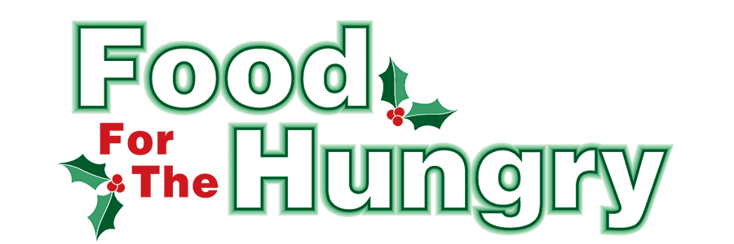

PRESS RELEASE
Contact Olivia Greenich Stern
Food For The Hungry Marketing Director
(330) 260-4059
oligreenich@gmail.com
April 4, 2023
FOR IMMEDIATE RELEASE

HEADLINE: Food For The Hungry welcomes new Board Members and says goodbye to three retiring from the board.

MOUNT VERNON, Ohio — On Wednesday, March 29, the Food For The Hungry board elected six new members to the board. The new board members are Michelle Coscia, Lisa Lloyd, Jay McLaughlin, Chelsea Porter, Melanie Snow, and Jared Stein.

Michelle Coscia runs a makeup business and works as a Service Representative at Lewis Clark Insurance Company in Mount Vernon. She has a heart for her community and over the years has supported various non-profits in Knox County. She is currently a member of Psi Iota Xi - Beta Upsilon Sorority, Relay For Life, and Dogwood Blossoms Chorus.

Lisa Lloyd is the Program Director at the Knox County Foundation where she oversees their grant and scholarship programs. Lisa shows her dedication and care for the community by serving on several boards. She has served as the Treasurer for Experience Mount Vernon since 2015 and has been on the board of United Way of Knox County since 2018 where she has held the roles of Community Investment Committee Chair, Board Chair, and Treasurer. Additionally, she is currently the President of the Kiwanis Club of Mount Vernon and just recently joined the Knox County Head Start board.

Jay McLaughlin grew up on a family dairy farm near Utica and now lives in Eastern Knox County. Jay has worked as the Marketing Director for CES Credit Union for the last 6 years, with a total of 20 years with the credit union. Jay believes in investing in his community. He is a lifelong member of Morgan Grange (Knox County), is in his second term of service on the United Way of Knox County board, is President-elect of The Exchange Club of Knox County, and is a member of Utica Merchants Association.

Chelsea Porter is the FaithWorks Coordinator in the Campus Ministries office at Mount Vernon Nazarene University. She oversees the local and global opportunities of service for MVNU students. She has been serving in this role for four years and now lives on the MVNU campus as her husband works as a Residential Director. Chelsea has skills in organizing volunteers and service projects and is passionate about serving people.

Melanie Snow has been a homeschool mom for 15+ years and has taught at a homeschool co-op for the past eight years. During political election season, Melanie serves as a Precinct Manager at various locations. Her family has volunteered at the Salvation Army for the past seven years: serving meals, and helping with backpack distribution, Food For The Hungry, and Christmas Distribution. As Melanie’s husband serves as the Pastor of First Baptist of Fredericktown, the Snow family regularly assists with community functions.

Jared Stein is a full-time Realtor who takes great pride in treating his clients and associates like family, working in Knox, Richland, and surrounding counties. Born and raised in the beautiful rolling hills of Eastern Knox County, Jared has a passion for the community around him. Being involved with the community and making a difference has always been one of Jared's top priorities. Jared joined the board of a local youth recreational sports program, Howard Youth League, in 2018, and became the League's Board President in 2019.

Food For The Hungry is excited to welcome these six new members and believes they will be assets to the board and the impact this organization has within Knox County.

With this election, the FFTH Board sadly says goodbye to previous members: John Feltman, Sandra Fithian, and Samantha Scoles. Each of these board members has diligently served FFTH and this community for many years and is well deserving of relief from their responsibilities on this board. In communication with the FFTH board about electing new board members, Interim President Austin Swallow said on March 27, “Our last Board meeting was a momentum-building decision for the future of Food For The Hungry as we adopted our revised by-laws. This ballot for electing new board members is another step forward. For some of you, it will be your last action as a member of the FFTH Board. Please accept my humble appreciation for your countless hours of love and dedication to this organization. I promise, as Interim President, to do my best to honor your commitment and ideals as we continue to help and care for our neighbors in Knox County as we address their food insecurity issues. You have six names before you, all qualified, all eager to stand on your shoulders. Thank you again to Curtis (Newland, Nominations Committee chair), who has worked so hard to prepare this slate. Thanks to those who nominated these candidates.”

John Feltman has served on the board since 2010 in various roles, most recently as Vice President. John was always eager to help FFTH in whatever way he could and was relied on by all for his sound insight. From moving boxes around to tracking donations on Drive Day, the FFTH team always knew they could rely on John.

Sandra Fithian has served on the FFTH board since 2018 as the Psi Iota Xi representative. The FFTH Elementary School drives would not have been possible without the dedicated leadership of Sandra. She was diligent in attending board meetings and offering a vital perspective!

Samantha Scoles has served with FFTH since 2017. In 2018, Samantha became the FFTH President and served for four Drive Seasons before resigning from her role at the end of the 2021 Drive. She remained present through the 2022 Drive Season to help guide the Interim President. Samantha has poured her time, energy, and heart into this organization and has been an invaluable asset to the FFTH Board.

John, Sandra, and Samantha’s hard work, knowledge, and dedication have helped FFTH flourish into what it is today. FFTH expresses great appreciation for its service to the board and the community of Knox County!
Find more information on FFTH, photos, radio interviews, videos, press releases, and more at FoodForTheHungryCares.org.

Food For The Hungry: Working together to care for our neighbors.
###

