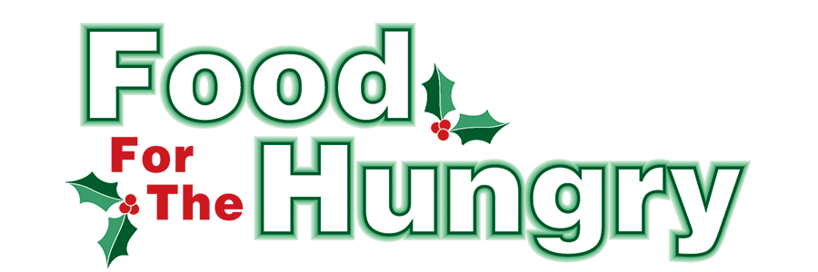

PRESS RELEASE
Contact Olivia Greenich Stern
Food For The Hungry Digital Content & Marketing Director
(330) 260-4059
oligreenich@gmail.com
NOV 24, 2023
HOLD FOR RELEASE ON NOVEMBER 24.

HEADLINE: Swing into the Holidays with Kenyon’s Snowflake Gala to raise funds for Food for the Hungry
MOUNT VERNON — On Friday, December 8, Kenyon College will host the 13th Annual Snowflake Gala, “Swing into the Holidays,” in support of Knox County Food For The Hungry.
The Gala will be held at the Lowry Center, 221 Duff St, Gambier, OH 43022, in the Multi-Activity Court, which will be transformed for the occasion. The Gala will begin with a cocktail reception at 6:00 PM, followed by dinner at 7:00 PM. The Gala dinner, prepared by the skilled chefs of AVI Food Systems, will feature a buffet of gourmet favorites prepared with locally sourced ingredients. There will be dishes to meet all dietary restrictions.
Entertainment will be provided by Kenyon Professor of Music Ted Buehrer, and the Knox Community Jazztet. The evening’s program will conclude with a Fund-a-Cause auction, providing guests with opportunities to support both the food-gathering and social-service activities offered by Food For The Hungry.
Krys and Joe Mortellaro, Knox County philanthropists and volunteers, will be recognized at the Gala with the William A. Stroud Award for Public Service. Hosts for the event are longtime Food For The Hungry supporters Kelly and Charlie Brenneman.
Tickets for the 2023 Snowflake Gala are priced at $100 per person with net proceeds benefiting Food For The Hungry. Tickets may be reserved by calling Kenyon at 740-427-5111 or by visiting www.FoodForTheHungryCares.org, which offers online payment options. Tickets must be purchased by Monday, December 4, 2023. All net proceeds and donations from the Fund-a-Cause auction benefit families and individuals in need in Knox County.
If you or your company would like to sponsor a dinner table ($1,000 for eight people) or support the Gala in some other way, please contact Kathryn Brechler Lake at 740-427-5111 or via email at lakek@kenyon.edu. All sponsors will be recognized in the program for the Gala. If you are unable to attend the 2023 Snowflake Gala but still wish to support Food For The Hungry, please consider making a contribution either online at www.FoodForTheHungryCares.org or via the U.S. mail to Food For The Hungry c/o Wilging, Roush & Parsons CPAs, 1684 Venture Drive, Suite B. Mount Vernon, OH 43050.

FFTH has set a goal of $260,000 for the 2023 campaign. Anyone can get involved by donating online or at one of the 12 collection points throughout Knox County on Friday, December 8. Visit www.FoodForTheHungryCares.org for continued opportunities to donate, volunteer, and find more information about upcoming events.

To view the Food For The Hungry Live Broadcast from the Memorial Theater at Knox Memorial on December 8 from 9:00 AM–4:00 PM, visit www.mvnu.tv. The broadcast can also be heard live on 100.9 FM, 93.7 HD2 WMVO, the WMVO listening APP, and WMVO.com. Live updates will also be available throughout the day on 90.9 FM WNZR and 93.7 The Super Q.

Food For The Hungry —Working Together To Care For Our Neighbors.
###

