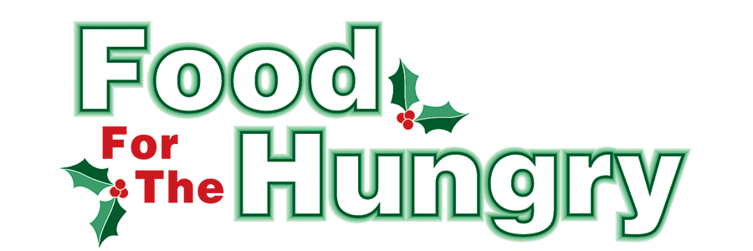

PRESS RELEASE
Contact Olivia Greenich-Stern
Food For The Hungry Marketing Director
(330) 260-4059
oligreenich@gmail.com
October 20, 2023
FOR IMMEDIATE RELEASE

HEADLINE: Donations needed for Fredericktown Christmas Walk Auctions

MOUNT VERNON, Ohio — This year marks the 23rd Annual Fredericktown Christmas Walk and Charity Auction. The Walk and Auction will occur on Saturday, December 2 from 4-7 P.M. This event supports Food For The Hungry, specifically raising funds for Fredericktown Interchurch, Fredericktown Salvation Army, and the Fredericktown Community Relief Fund.

Part of the event is an online auction that will run from November 24-30. There will also be the Scrumptious Food Auction, taking place during the Christmas Walk on December 2 in the Council Chambers (formerly Senior Citizen Building). There is a need for donations from the community for the auctions. Families, friends, neighbors, churches, and local organizations are encouraged to donate baskets, service offerings, and gift certificates. The Fredericktown Christmas Walk and Auction is only possible with the help of community members.

Virtual auction donations can be dropped off November 6-10 at the Fredericktown School Administration Building, 117 Columbus Rd. from 8 A.M. to 4 P.M. Items for the Scrumptious Food Auction can be dropped off between 12 P.M. and 3 P.M. on the day of the walk at the Council Chambers.

Additional information on the Christmas Walk and Auction will be shared closer to the date of the event. Be on the lookout for Food For The Hungry updates on the FFTH social media pages and website, FoodForTheHungryCares.org. Follow the Fredericktown Annual Christmas Walk and Auction Facebook Page and Instagram, @FredericktownChristmasWalk, for updates on the Christmas Walk. As the event draws closer, please check the Fredericktown Annual Christmas Walk and Auction Facebook Page for any changes or updates.

Food For The Hungry: Working together to care for our neighbors.
###

