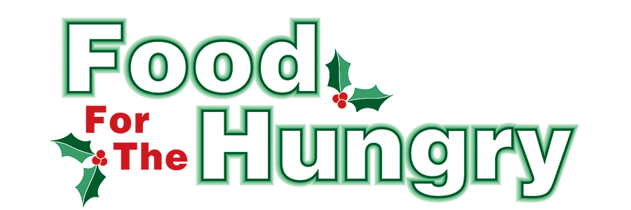

**PRESS RELEASE**

**Contact Olivia Greenich Stern  
Food For The Hungry Digital Content & Marketing Director  
(330) 260-4059  
oligreenich@gmail.com**

**May 30, 2024**

**FOR IMMEDIATE RELEASE**

**HEADLINE: Food For The Hungry grants $29,500 for Summer Food Programs**

MOUNT VERNON, Ohio—Food For The Hungry opened a special Summer Grant process to help organizations throughout Knox County eliminate food insecurity during the Summer. Because of the overwhelming generosity of Knox Countians during the 2023 FFTH Drive, reserve funds were set aside for Summer Grants. Through the Summer Grants, FFTH continues to honor the wishes of its donors to support their local community year-round.

The grant prioritized food initiatives that supplement food for children and teens whose primary source of food is the free or reduced breakfast and lunch given to them during the school year. Other food programs were also encouraged to apply and there was a large response to the grant application.

After great consideration of the applications, FFTH has chosen 15 organizations as Summer Grant recipients. FFTH is honored to award a total of $29,500 in grant funds to these local organizations:

***Alcohol and Drug Freedom Center of Knox County - $1,000.00***

***Central Christian Church Food Pantry - $3,000.00***

***Covenant Church Food Pantry - $2,000.00***

***East Knox Local Schools - $3,000.00***

***First Church of the Nazarene - Father's Table/Father's Pantry - $3,000.00***

***Gay Street United Methodist Hot Meals - $2,000.00***

***Hot Meals, First Congregational United Church of Christ - $2,000.00***

***Knox Area Transit - $2,000.00***

***Lazarus Life Ministries - $1,000.00***

***Martinsburg Activity Center - $2,000.00***

***MV SDA Hill Church - Knox County Hot Meals - $1,000.00***

***New Directions Domestic Abuse & Rape Crisis Center of Knox County - $1,500.00***

***The Church On The Rise Food Pantry Ministry - $2,000.00***

***The Salvation Army - $2,000.00***

***Cornerstone Community Church - $2,000.00***

When asked about the grants, Lisa Lloyd - Vice President of FFTH and chair of the FFTH Grant Committee - said "I am thrilled that Food for the Hungry was able to award $29,500 to 15 outstanding organizations dedicated to providing food to those in need during the critical summer months. These grants will go towards their continued efforts in ensuring that no one in our community goes hungry."

Thank you to every individual in Knox County who continuously believes in the vision of Food For The Hungry, and the desire to better our community. The generosity displayed each year makes grants like these possible.

To learn more, donate, or find photos, videos, and radio interviews from the 2023 Drive, visit [www.FoodForTheHungryCares.org](http://www.foodforthehungrycares.org).

***Food For The Hungry—Working together to care for our neighbors.***

###