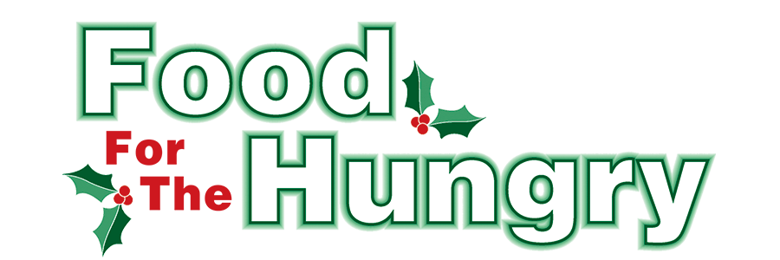

PRESS RELEASE
CONTACT: Olivia Greenich Stern
Food For The Hungry Marketing and Digital Content Director
330-260-4059
Monday, April 4, 2024
FOR IMMEDIATE RELEASE
HEADLINE: Food For The Hungry offers Summer Grant opportunities for Summer distribution programs

MOUNT VERNON — The Food For The Hungry board has announced a Summer grant opportunity directed to reach churches, agencies, and organizations that provide Summer food distribution programs to fill the gap for families with children home from school. Thanks to the outstanding generosity of Knox County, the funds raised during the FFTH Drive Season exceeded the 2023 goal of $260,000. The board has designated $25,000 of the excess funds for Summer grants.
Organizations may apply for an FFTH Summer Grant for programs that will provide food assistance and distribution through the Summer months until Sept 30, 2024. Priority will be given to programs that assist youth who rely on meals provided by schools during the school year. Groups that provide assistance outside the traditional Mid-Ohio Food Collective income guidelines are strongly encouraged to apply. All other food initiative organizations are also welcome to submit an application.
An online application is available at FoodForTheHungryCares.org. The application process is open from Monday, April 15, through Tuesday, April 30, at 12 p.m. Awards will be announced at the end of May.
For more information or assistance on the grant application and process, please email contactffthcares@gmail.com.

For photos, videos, and radio interviews from the 2023 drive, as well FFTH history and continued opportunities to donate, please visit www.FoodForTheHungryCares.org. The 2023 Drive broadcast is available on demand for a full year at www.mvnu.tv.

Thanks to this generous community and continued support as we work together to care for our neighbors.

###

