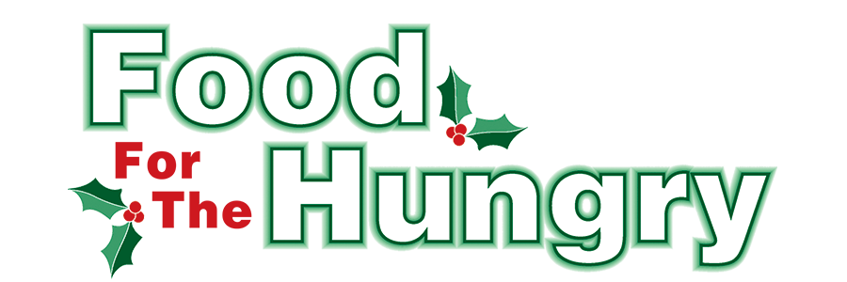

PRESS RELEASE
Contact Olivia Greenich Stern
Food For The Hungry Digital Content & Marketing Director
(330) 260-4059
contact@foodforthehungrycares.org
Feb 20, 2026.
FOR IMMEDIATE RELEASE

HEADLINE: Feeding the Community with Heart: Foster Ministry House’s Food Services
MOUNT VERNON, OH — In a landscape where hunger remains a pressing challenge, Renee Reiss and the Foster Ministry House at First Church of the Nazarene in Mount Vernon are proving that agility and empathy are the keys to effective service. As the only organization in the area besides the Salvation Army to offer both a weekly hot meal and a monthly food distribution, the ministry is strategic and mindful with its operations to ensure no neighbor goes hungry.

Strategic Shifts for Greater Reach
In August 2025, the Foster Ministry House moved its monthly food distribution from the third Saturday to the fourth Saturday of each month from 9 AM to 11 AM. This decision, spearheaded by Director Renee Reiss, comes after a careful analysis of community needs.
"We noticed a decline in pantry attendance over the last year and realized we were overlapping with two other local pantries," Reiss explained. "By moving to the fourth Saturday, we fill a critical gap in the month when families often find their cupboards bare and their resources stretched thin."
An individual needs to bring identification and proof of address to receive food at the monthly distribution.

A Hybrid Approach to Dignity
The ministry’s distribution system utilizes a "hybrid" model designed to provide both efficiency and dignity. Rather than receiving a pre-packed box, guests register and "order" items from specific food groupings based on their family size.
- The Process: Volunteers act as "runners" to a packing station, while a dedicated team delivers the groceries directly to the guest’s vehicle.
- The "Extra" Touch: While the program follows the standard "three meals for three days" guideline, Reiss makes it a point to include "extras" whenever possible—a small gift of grace she hopes to maintain despite tightening supplies.

Overcoming Supply Chain Challenges
The mission faces headwinds as federal cuts and policy changes at the Mid-Ohio Food Collective have impacted availability. In 2025, Reiss noted a significant reduction in free offerings and a noticeable dip in protein and meat options.
Despite these hurdles, the ministry thrives through a robust network of support. Financial backing comes from First Church of the Nazarene and the Food For The Hungry (FFTH) grants, which account for nearly 20% of the budget. First Church of the Nazarene received $6,000 from the FFTH 2025-2026 Winter Grant cycle - dedicated to the hot meal program and food pantry.
"The support from FFTH helps us make our dreams a reality," says Reiss. "We are always thinking about what’s next and how we can reach the next person in need."

Community-Powered Service at the Hot Meal
Success at the Foster Ministry House is a team effort. Each week, a dedicated crew of 4–5 volunteers manages the Wednesday Hot Meal program (available for both dine-in and carry-out from 5 PM - 6 PM), while 10–12 volunteers power the monthly distribution. This volunteer force is a diverse blend of church members, high school students, and students from Mount Vernon Nazarene University and Kenyon College. The Hot Meal serves 60 to 80 people each week.
Beyond the church walls, the ministry maintains an ongoing partnership with the East Knox School District, ensuring students have access to nutrition on weekends throughout the school year, and during holiday and summer breaks. This partnership and ministry received a $3,000 FFTH 2025-2026 Winter Grant.

About Foster Ministry House
The mission of the Foster Ministry House is to meet the physical needs of the community while fostering relationships that share the love of Jesus. Through hot meals, grocery distribution, and school partnerships, they serve as a vital safety net for Knox County. FFTH is proud to partner with Foster’s efforts to reduce hunger in Knox County.
Foster Ministry House is located at 723 Coshocton Ave, Mt Vernon, OH 43050.
Hot Meal - Wednesdays for dine-in or take-out from 5 PM - 6 PM.
Food Pantry - Fourth Saturday of each month from 9 AM to 11 AM.
Website: wwwFirstNaz.net/Foster-Ministry-Center
Email: fatherstable807@gmail.com
FFTH Winter Grants are funded through the generous donations of people in Knox County who support FFTH’s mission and goal each year. FFTH collected $394,301.89 and 23.5 truckloads of food for its 2025 Drive. To learn more about grant recipients, visit www.FoodForTheHungryCares.org. FFTH history, photos, videos, and much more can also be found on the website. 2026 marks 45 years of FFTH!
Food For The Hungry - Working Together To Care For Our Neighbors.

###

