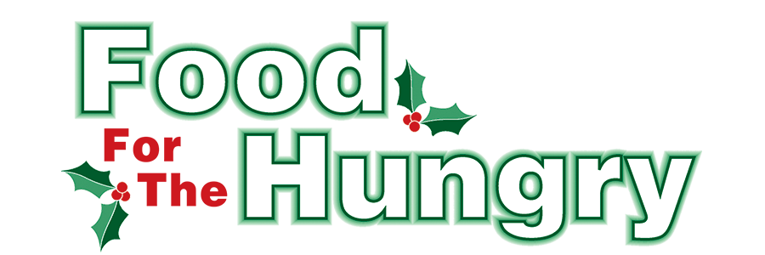

PRESS RELEASE
Contact: Olivia Greenich Stern
Food For The Hungry Digital Content & Marketing Director
(330) 260-4059
contact@foodforthehungrycares.org

May 26, 2026
FOR IMMEDIATE RELEASE
HEADLINE: Food For The Hungry grants $30,500 for Summer Food Programs

MOUNT VERNON, Ohio—Food For The Hungry (FFTH) is awarding 12 Summer Grants, totaling $30,500. The FFTH Summer Grant program began in 2020, when the COVID-19 lockdown heightened awareness of child hunger throughout the United States. In Knox County, Ohio, 30 to 40 percent of students rely on the free breakfasts and lunches they receive at school each day. Hundreds of children throughout the county do not have access to food during the weekends and school breaks. During this award cycle, the FFTH Grants Committee focuses on programs that give children access to nutritious meals during summer break, while still supporting other pantries and hot meals throughout the county.

Funding for Summer Grants comes from the generous donations made by community members and organizations to the annual Drive Goal. Each year, FFTH sets aside a portion of the Drive’s proceeds for the Summer Grant program. As the FFTH Grants Committee reviewed the needs of this year’s applicants, they decided to pull additional funds from the excess of 2025’s Drive Goal. The people of Knox County raised an astounding $394,301.89 for the 2025 Drive, over $50,000 more than the Drive Goal. When the Drive Goal is exceeded, it allows FFTH to give additional grant funds or special grants when needed.

After great consideration of the applications, FFTH has chosen the following 12 organizations as Summer Grant recipients. FFTH is honored to award a total of $30,500 in grant funds to these county projects involving food assistance. The recipients will use their grants for food initiatives that range from food pantries to special meals and activity bags for children.

Grants of $5,000:
- First Church of the Nazarene East Knox Food Bags
- This grant will be used to purchase food for families from East Knox and Danville schools who rely on the breakfast and lunch programs during the school year and face gaps in summer nutrition. First Naz aims to provide 40-60 boxes bi-weekly to both schools.

- First Church of the Nazarene Father’s Table Pantry and Hot Meal.
- This grant will be used to purchase food to sustain the weekly hot meal and pantry programs (which serve 81+ households with children) throughout the summer months. Hot meals attendance has been 60-80 people each week.

Grants of $2,500:
- Central Christian Church Food Pantry
- They operate a monthly food pantry through the Central Church facility in Mount Vernon. Their clients receive a box of canned goods, including soups, pasta, canned vegetables, and canned meat (when available). This grant will be used to purchase perishable items unavailable through Mid-Ohio Food Bank—bread, fresh fruit, dairy products (yogurt, string cheese), and beverages—for approximately 150 children per month during June, July, and August.
- Church on the Rise Food Pantry
- They provide food and other products to people in need in the county by distributing food/other items every third Saturday of the month. This grant will help them purchase food throughout the summer to ensure school-age children without sufficient resources receive adequate meals.
- Covenant Church Food Pantry
- Covenant Church Food Pantry is a group of volunteers (mostly members of the church) who work hard to obtain food and distribute it monthly to families in need. The money will be used to increase food supply for families with children who lose access to school-provided meals during summer break.
- Martinsburg Activity Center
- The Activity Center provides free lunches to children during the summer months. 60 people will receive lunch Monday through Friday.
- The Escape Zone - EZ Diner
- The Escape Zone will provide meals to EZ children on Friday nights. The aim is to provide kid-friendly meals that include healthy items like fresh fruits and vegetables and lean protein. 70 people are served each Friday.

Grants of $2,000:
- Knox County Transit
- Knox County Transit will use its grant funds to purchase 28 wheeled carts to allow specifically identified food-insecure riders (including wheelchair users) to safely transport large grocery loads on public transit.
- Mount Vernon Seventh-Day Adventist Hill Church – Knox Hot Meals
- The funds will be used to supplement donations that cover food and paper supply costs for weekly hot meals - open to all community members, including school-age children and families.
- The Salvation Army
- This grant will provide healthy snacks and meals (breakfast, AM snack, lunch, PM snack) for up to 112 children per day in childcare and summer day camp programs at the Salvation Army, Monday–Friday.

Grants of $1,000:
- Afterglow Christian Mission House
- This grant will cover food costs for daily meals (breakfast and dinner) open to all community members. Afterglow is anticipating increased attendance from school-age children during summer break.
- CHOMP Ministries
- Holiday fruit baskets will be distributed to 60+ low-income families in December, with a goal of expanding distribution by 10% over 2025 levels. FFTH awarded CHOMP $2,500 for the 2025 Winter Grant cycle to fund its Summer Produce Market.
Thank you to every individual in Knox County who continuously believes in the vision of Food For The Hungry and the desire to better your community. The generosity displayed each year makes grants like these possible!

Visit www.FoodForTheHungryCares.org to learn more about FFTH and follow FFTH on Facebook (@FoodForTheHungryKnoxCounty) and Instagram (@FFTHCares) to stay current on all things FFTH.
Food For The Hungry—Working Together To Care For Our Neighbors.
###

Photo Caption: Volunteers pack food boxes for the Father’s Table Food Pantry at First Naz in Mount Vernon.

