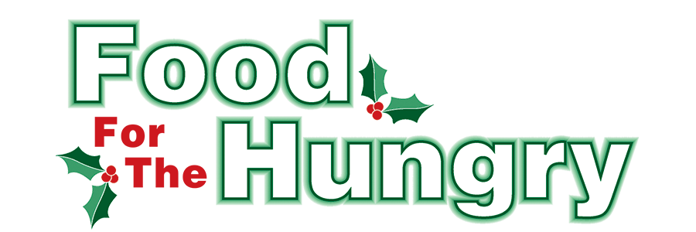

PRESS RELEASE
Contact: Olivia Greenich Stern
Food For The Hungry Digital Content & Marketing Director
(330) 260-4059
contact@foodforthehungrycares.org

April 8, 2026
FOR IMMEDIATE RELEASE
HEADLINE: Food For The Hungry in search of Annual Drive and Community Relations Director
MOUNT VERNON — Food For The Hungry is in search of an Annual Drive and Community Relations Director to join its team. This is a rewarding position as the Annual Drive and Community Relations Director is essential to the Food for the Hungry team in its nonprofit efforts focused on providing food and financial support to entities striving to reduce hunger in Knox County, Ohio. The Director position is ideal for someone who is relational, organized, needs a flexible schedule, and cares about bettering their community.
The Director’s main responsibility is to oversee and coordinate the annual FFTH Drive in November and December. Throughout the year, the Director manages various grant applications and award deadlines, coordinates with Community Partners and grant recipients, presents annual operating budget requests, coordinates marketing and promotional initiatives with the Digital Content and Marketing Director, and works closely with the FFTH board on FFTH matters. The Director should positively represent FFTH to the public at various events and venues.
FFTH encourages applicants to apply by Friday, April 24th.
Time Commitment and Work Environment
The Director is an hourly position. While the position is not full-time, hours vary depending on the time of year. January and October: Approximately 15–20 hours per week. February–September (“off” months): Approximately 30–40 hours per month. November and December: The busiest months, averaging 25–30 hours per week. Drive Week (second week of December) and the following week: Require an “all-in” approach with additional time as needed to ensure success.
The Director position is hybrid remote in Knox County, Ohio. Organizational work can be done remotely, while meetings are encouraged to build relational connections and may happen throughout the county.
Required Skills and Qualifications
- Strong organizational and project management skills.
- Exceptional attention to detail with demonstrated ability to follow through on tasks.
- Excellent written and verbal communication skills.
- Comfortable representing the organization in public and community settings.
- Ability to manage multiple projects and deadlines simultaneously.
To learn more and apply, visit https://www.indeed.com/job/annual-drive-and-community-relations-director-29c9e662a3c885cd
Or find the application at www.FoodForTheHungryCares.org
Applications received by Friday, April 24th, will have first priority.
A cover letter is required with each application. Cover letters can be sent via email to lisalloyd@foodforthehungrycares.org. The cover letter should indicate why you are applying for this position and what skill sets and qualities make you an ideal candidate.
Further questions can also be emailed to Lisa at the email address above.
Follow FFTH on Facebook (@FoodForTheHungryKnoxCounty) and Instagram (@FFTHCares) to stay current on all things FFTH. To learn more about FFTH, donate, or find photos, videos, and more, visit www.FoodForTheHungryCares.org.

Food For The Hungry—Working Together To Care For Our Neighbors.
###

