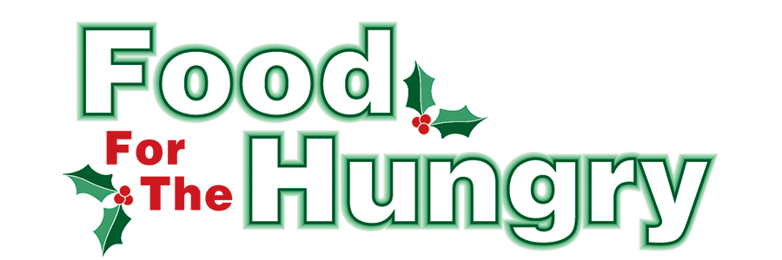

**PRESS RELEASE**

**Contact: Olivia Greenich Stern  
Food For The Hungry Digital Content & Marketing Director  
(330) 260-4059  
oligreenich@gmail.com**

**June 10, 2024**

**FOR IMMEDIATE RELEASE**

**MOUNT VERNON: Food For The Hungry Helps Seniors at the Mount Vernon Farmers Market**

As a part of the 2024 Summer Grant Program, Food For The Hungry (FFTH) is awarding the Mount Vernon (MV) Farmers Market with $2,000 for the purchase of food tokens for seniors.

The MV Farmers Market offers various local, state, and federal-funded food insecurity programs for Knox County. One of these programs is the Area Agency on Aging Senior Vouchers. In 2023, over $10,000 worth of vouchers were distributed in Knox County through this program. Over $8,000 were redeemed as seniors received a balanced diet.

For 2024, the State of Ohio changed the program to a digital format. The program would require participants age 60 and older to use smartphones to make transactions at a market. Vendors now also need a digital device to scan a QR code on the elder's smartphones to transfer the program’s dollars. When the MV Farmers Market team heard of this new state system, they were concerned with the challenge this would cause for vendors and customers. One of the concerns was that seniors who need food assistance would withdraw from the program because of the added digital challenge.

The MV Farmers Market is committed to user-friendliness for all its patrons. To continue accessibility to fresh produce for seniors, the Market Coordinator will perform all QR scanning. After a customer’s QR code is scanned, they will receive tokens that will function as their form of payment for vendors. Because this new state system was not announced until late Spring 2024, the MV Farmers Market had not budgeted for the tokens needed.

The MV Farmers Market reached out to FFTH with a request of $2,000 to help with the purchase of tokens and the transition into this new program. The FFTH board approved this request as a part of its Summer Grant program. The $2,000 grant comes from donations that exceeded the 2023 FFTH Drive goal. This grant would not be possible without the generous support of Knox County for FFTH.

FFTH President Austin Swallow commented on this Summer Grant Award to the Market, saying “To me, this request is a natural extension of the Summer Grant we awarded the Knox Area Transit, providing transportation to the Farmers Market. What a better way to assist those already going to the market! We know families today are more intergenerational than in recent years, as more grandparents are raising their second or third set of children. This grant ties in with FFTH’s Spring/Summer priority of supporting children who need supplemental food for the Summer and we are proud to be a small part of helping those with food insecurity in our county.”

Follow FFTH on Facebook (@FoodForTheHungryKnoxCounty) and Instagram (@FFTHCares) to stay current on all things FFTH. To learn more about FFTH, donate, or find photos, videos, and more, visit [www.FoodForTheHungryCares.org](http://www.foodforthehungrycares.org).

***Food For The Hungry—Working together to care for our neighbors.***

###