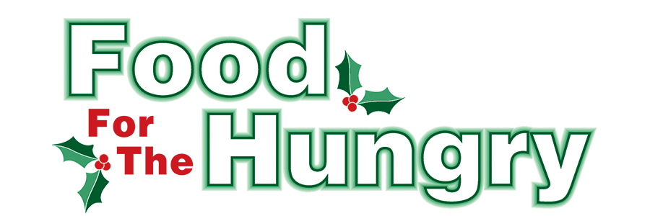

PRESS RELEASE
Contact Olivia Greenich Stern
Food For The Hungry Marketing Director
(330) 260-4059
oligreenich@gmail.com
September 12, 2023
FOR IMMEDIATE RELEASE
HEADLINE: Food For The Hungry Winter Grant Application Opens Sept. 18.

MOUNT VERNON —The Food For The Hungry Grant Application is opening early this year! The Food For The Hungry of Knox County’s grant application process for the 2023 campaign opens Monday, Sept. 18 at 8 a.m. and will remain open until Saturday, Sept. 30 at 12 p.m. Applications submitted after 12 p.m. on Sept. 30 will not be accepted.
Each year, a portion of the funds raised during the FFTH Winter Drive is allocated to the Winter Grant recipients. The Winter Grants recipients are non-profit groups in Knox County that distribute food to those in need.
Grants are awarded with consideration of the number of people being served, the number of monthly volunteers involved, and other factors detailed in the application.
The grant application is located at FoodForTheHungryCares.org. The application link can be found on the home page or under the ‘Who We Help’ tab. Applications are due by Saturday, September 30, 2023, at 12:00 p.m. Grant awardees will be notified by Monday, October 16, and announced the same day.
Grant recipients will be featured during the Food For The Hungry live-stream and radio broadcast on Friday, Dec. 8 at the Memorial Theater inside the Knox Memorial.
To keep up to date on Food For The Hungry news, follow FFTH on Facebook at @FoodForTheHungryKnoxCounty and on Instagram at @ffthcares.
If you are choosing to support Food For The Hungry through a community event, make sure to fill out the community event form on the FFTH website by September 15th so that FFTH can promote your event.
For more information on the grant application process, volunteering, and donating to FFTH contact Executive Director Lisa Mazzari at (740) 398-0569 or email LisaM.ffth@gmail.com.
Thanks to this generous community and continued support as we work together to care for our neighbors.
###

