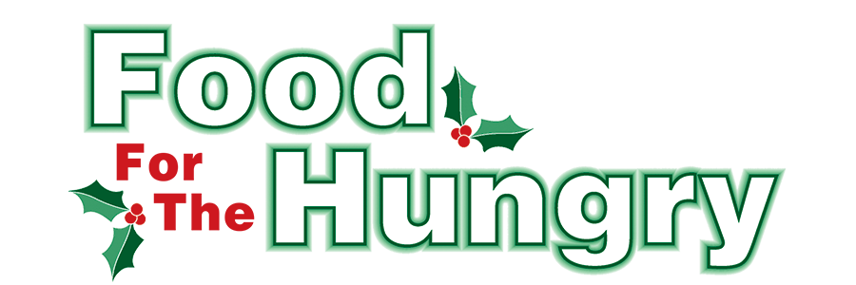

PRESS RELEASE
Contact Olivia Greenich Stern
Food For The Hungry Digital Content & Marketing Director
(330) 260-4059
Contact@FoodForTheHungryCares.org
December 2, 2025
FOR IMMEDIATE RELEASE
HEADLINE: Pop-up Food Pantries bring Knox County together in the midst of need.
MOUNT VERNON, OH— Food For The Hungry of Knox County (FFTH), Interchurch Social Services of Knox County (ISS), and Knox County Foundation (KCF) partnered together to organize two Pop-Up Food Pantries in November to help people in need. By mid-October, the government shutdown continued to drag on, and talk began circulating that SNAP (Supplemental Nutrition Assistance Program) benefits would be postponed for recipients in November. Carolyn Fergus, Director of ISS, had already seen an increase in food pantry visitors in 2025. In 2022, Interchurch Social Services' food pantry served nearly 200 families each month. That number rose to over 700 families each month in 2025.

Recognizing that the SNAP postponement would significantly impact the community, Fergus started planning a unique response to the need - Pop-Up Food Pantries. Lisa Lloyd of KCF and Austin Swallow of FFTH quickly agreed to join the effort to organize the first pantry. With Fergus strategically ordering bulk food from Mid-Ohio Food Collective, Lloyd recruiting volunteers, and Swallow helping with organizational tasks and marketing efforts, the plan for a November 1 pop-up pantry came to fruition with hopes of another later in November.

A large truck of food was delivered to ISS on October 16. Volunteers from KCF were ready to load pick-up trucks with the food to take it to the pop-up location donated by Habitat for Humanity. Cold items were stored in Church on the Rise’s freezers until the pantry. The pantry would provide three meals a day, for three days, for each person in a family.

On November 1 at 8 AM, dozens of volunteers gathered to prepare the pop-up pantry. Some came on their own, while others volunteered in groups from Knox Community Hospital, Knox Public Health, Kenyon College, Mount Vernon Nazarene University, and Behavioral Healthcare Partners. Everything was organized quickly, and people who needed food started lining up at 8:30 AM for the pantry that wasn’t scheduled to open until 10 AM. With quick work from the volunteers, the pantry was able to open at 9 AM and served nearly a hundred people by the scheduled 10 AM opening. Recipients told the check-in desk the number of people in their household before they were given a grocery cart to walk through the distribution line. Volunteers offered each recipient an item from their pallets of food: juice, peanut butter, cereal, freezer meals, and much more. Over 200 households were served on November 1.

Following a quick celebration of the successful pantry, Fergus, Lloyd, and Swallow began planning another for November 22. Volunteers from the Mount Vernon Probation Office helped unload a large truck of food a week before the pantry. Church on the Rise again volunteered its food pantry refrigerators and freezers to store cold items until the distribution, and Center of Hope offered a large load of produce, eggs, and milk. IPT America offered its warehouse in Mount Vernon for the November 22 pantry. On that crisp and sunny November morning, volunteers again assembled for the food pantry. Similar to the November 1 pantry, volunteers came on their own and with local organizations.

With the setup of this location, many volunteers assembled “large” and “small” boxes of food inside the warehouse, and some volunteers manned the produce section outside. People in need of food filled the parking lot by 9 AM for the 10 AM scheduled start time. By 9:30 AM, people were receiving food. Once a household checked in, they had the opportunity to pick out some produce and then go back to their car to pull it around for their box of food. Carolyn Fergus and Austin Swallow stood in the parking lot awaiting the cars. As a car pulled up for their food, they would tell Fergus or Swallow the size of their family or whether there were multiple households riding in the same car. Depending on the size, Fergus or Swallow would call out a loud “One small box!” or “Two large boxes!” before volunteers would bring out the correct amount of food to load into a recipient’s car. Around 150 families in need were served, and each volunteer felt the pantry was well worth the effort. When asked about the pop-up pantries, Swallow said, “They showed the best of our county. So many volunteers, all willing to do whatever. Two different styles of pantries, but equally gracious hosts. Everyone we called to help said yes. Everyone!” The pop-up food pantries were a taste of goodwill and hope for Knox County, not just for the families in need, but for the volunteers and people who need a reminder that there are good things happening in this world.

Food For The Hungry of Knox County is continuing to do good for this community as it strives to collect $340,000 and as much non-perishable food as possible for its 2025 campaign. 68% of the Drive Goal and all food collected goes to FFTH community partners, Interchurch Social Services of Knox County and The Salvation Army in Mount Vernon. The remaining funds will be awarded in 2026 through both Summer Grants (8%) and Winter Grants (14%), as well as a small portion set aside for organizational expenses (10%). FFTH just awarded a total of $55,000 in 2025 Winter Grants to 23 local organizations - the highest amount granted in FFTH’s history.

Follow FFTH on Facebook (@FoodForTheHungryKnoxCounty) and Instagram (@FFTHCares) to stay up to date on all things FFTH. Get involved by attending events, donating, volunteering, or even hosting your own event for FFTH! If you are hosting an event or collection, make sure to fill out the Community Event/Collection Form on the FFTH website.

To learn more about FFTH, donate, or find photos, videos, and more, visit www.FoodForTheHungryCares.org. To volunteer with FFTH, fill out the volunteer form on FFTH’s website. The Food For The Hungry Live Broadcast and Drive Day is December 12 from 9:00 AM–5:00 PM. FFTH Live will be available for live stream from the Memorial Theater at Knox Memorial on www.mvnu.tv and the Food For The Hungry of Knox County YouTube channel. The broadcast can also be heard live on 100.9 FM, 93.7 HD2 WMVO, the WMVO listening APP, and WMVO.com. Live updates will also be available throughout the day on 90.9 FM WNZR and 93.7 The Super Q. FFTH Live and Drive Day is a celebration of Knox County! This is a Knox County tradition you won’t want to miss!

Food For The Hungry—Working together to care for our neighbors.
###

