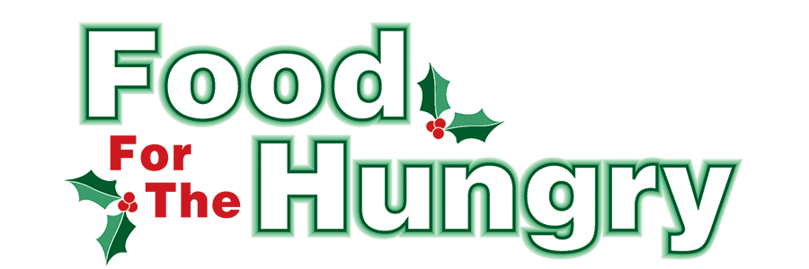

PRESS RELEASE
Contact Olivia Greenich Stern
Food For The Hungry Digital Content & Marketing Director
(330) 260-4059
oligreenich@gmail.com
NOV 29, 2023
FOR IMMEDIATE RELEASE

HEADLINE: Interchurch Social Services purchases new refrigerator with support from Food For The Hungry
MOUNT VERNON — In Spring 2023, Executive Director of Interchurch Social Services (ISS) of Knox County Carolyn Fergus called Food For The Hungry’s Interim Board President Austin Swallow with a proposal.
ISS is a FFTH Community Partner that receives continuous support from FFTH. However, ISS required additional funds for a new refrigerator to store fresh meat and produce for its pantry at the Mount Vernon location.
Swallow responded that he would take the matter to the FFTH Board. ISS, under Fergus' leadership, has taken many steps to increase the amount of food available to its clients, not only in Mount Vernon but also at its Centerburg, Danville, and Fredericktown locations. FFTH knew it would be an investment that would directly benefit clients who need fresh meat and produce.
FFTH does not hold capital funds to expense. Therefore, the FFTH Board agreed to set aside $5,000 of the excess funds raised from the 2022 FFTH Drive Goal to serve as a capstone gift for the ISS refrigerator. The $5,000 would be given to Fergus when ISS had raised the remainder of the cost needed to purchase the refrigerator. It was a joyous day in early November when Swallow was able to present Fergus with the check. The refrigerator was already in place and being used for its intended purpose.
This FFTH capstone gift was made possible through the generous support of Knox County in 2022. The 2023 FFTH Drive Goal is $260,000. Meeting this goal will enable FFTH to continue its support of Community Partners and food initiative organizations throughout Knox County. Exceeding this goal will make Summer Grants and gifts like this possible in 2024. Consider supporting FFTH this Drive season by donating on the FFTH website or at the various collection points on Drive Day, Friday, December 8, from 9 A.M. to 3 P.M.
Follow FFTH on Facebook (@FoodForTheHungryKnoxCounty) and Instagram (@FFTHCares) to stay up to date on all things FFTH. Get involved by attending events, donating, volunteering, or even hosting your own event for FFTH! If you are hosting an event, make sure to fill out the Community Event Form on the FFTH website.
To learn more about FFTH, donate, or find collection points, media, and more, visit www.FoodForTheHungryCares.org. To volunteer with FFTH, call or text Lisa Mazarri at 740-398-0569. The 2023 FFTH Live Broadcast will air on December 8 from the Memorial Theater in Knox Memorial on East High Street in Mount Vernon.

Food For The Hungry—Working together to care for our neighbors.
###

