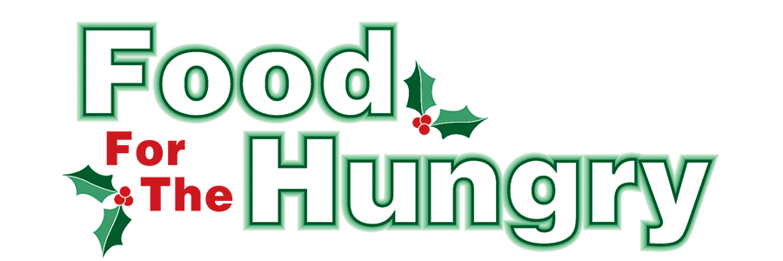

PRESS RELEASE
Contact Olivia Greenich Stern
Food For The Hungry Marketing Director
(330) 260-4059
oligreenich@gmail.com
NOV 1, 2023
MEDIA PARTNERS: IN AN EFFORT TO REACH AS MUCH OF KNOX COUNTY ON THE SAME DAY, PLEASE HOLD THIS RELEASE FOR PUBLICATION AND POSTING ON NOVEMBER 1st.

HEADLINE: Food For The Hungry Kicks Off Drive Season with Goal of $260,000 and Announces Winter Grant Recipients

MOUNT VERNON, Ohio—The annual Food For The Hungry Drive officially kicked off on Wednesday morning, Nov. 1, as a community-wide effort to raise food and funds for Interchurch Social Services, The Salvation Army, Center of Hope, and other organizations throughout the county with food assistance initiatives. This year, Food For The Hungry (FFTH) has established a financial Drive Goal of $260,000 and hopes to collect as many non-perishable food items as the community can donate.

Food for the Hungry is a nonprofit organization focused on providing food and financial support to entities striving to reduce hunger in Knox County. In order to accomplish this mission, there is a food and money drive made up of multiple events culminating into a one-day simulcast (broadcast online and via the radio) on the second Friday of December. The 2023 Drive will take place on December 8, from 9 A.M. to 4 P.M. The food and funds collected by FFTH are distributed to local agencies that work firsthand with those in need of food in Knox County.
It is no mystery that inflation has altered the lives of countless people. While many people feel the weight of their grocery bills getting higher, the number of people who cannot afford any food to feed their families or themselves is rising. The Mid-Ohio Food Collective (formerly known as Mid-Ohio Food Bank) has also suffered from the economy. Mid-Ohio Food Collective is a major source of food for the agencies that are supported through FFTH. In two years, the buying power of $1 at the Mid-Ohio Food Collective has FALLEN from $11.00 to $4.89.
Despite the decline in the buying power of $1, FFTH is confident that those less fortunate in this community can continue to count on its generous donors to help disrupt the food insecurity in Knox County. A food pantry can still use a single $1 to buy $4.89 worth of food from Mid-Ohio Food Collective. That means a couple of dollars could provide dinner for an entire family. Therefore, no effort to support the FFTH mission is too small! Fundraising events for the 2022 FFTH Drive ranged from county-wide Service Club competitions to Middle School girls selling bracelets. You can make a difference by participating in the 2023 FFTH Drive!
The people of Knox County exceeded the Drive Goal last year and raised $353,367.86 and 20.7 truckloads of food. This allowed for the FFTH leadership team to reframe the process for Summer and Winter Grants that are awarded to local organizations with food initiatives. With the excess funds from the 2022 FFTH Drive, $25,000 in Summer Grants were awarded to Knox County organizations that focused on feeding children who rely on school meals throughout the school year.
Additional funds from the 2022 FFTH Drive were allocated for the Winter Grants that will enable local organizations to provide food to those in need through the 2023-2024 Winter. To assess the community's needs, FFTH opened its Winter Grant Application from September 18-30 and received an exceptional response. Each organization was able to express its particular needs. After careful review of the applications by the FFTH grant committee, FFTH is honored to award a total of $40,000 in grant funds to 21 different organizations! The grant recipients are as follows:

Central Christian Church - $2,000
CHOMP - $2,000
Church on the Rise - $2,000
Cornerstone Community Church - $2,000
Covenant Church - $2,000
Escape Zone - $2,000
First Congregational United Church of Christ - $1,500
First Presbyterian Church - $2,000
Freedom Center: A Drug & Alcohol Rehab Center - $1,000
Gay Street United Methodist Church - $2,000
Jaque Cordle Children’s Fund - $3,000
Knox County Career Center - $2,000
Knox Learning Center - $2,500
Lazarus Life Ministries - $1,500
LifePoint Church - $2,500
New Directions Domestic Violence Support Center - $1,000
Say a Prayer Ministries - $1,500
Sharing Shed of Millwood Church of Christ - $1,000
The Father’s Table of First Church of the Nazarene- $3,000
TouchPointe Marriage and Family Resources - $1,500
Winter Sanctuary Emergency Homeless Shelter - $1,500

With FFTH grants, these organizations will be able to continue their good work to reduce hunger in Knox County. Tune in to FFTH Live Broadcast on Dec. 8 to learn more about these organizations as they are featured throughout the day.

Thank you to every individual and organization in Knox County who continuously believes in Food For The Hungry's vision and the desire to better our community. The generosity displayed each year makes grants like these possible. In the new FFTH grant framework, money and food collected from the annual Drive will be allocated to its community partners (Interchurch Social Services, The Salvation Army, Center of Hope), and a portion of the money will be designated for Winter Grants of the following Winter season. Funds that exceed the goal will enable FFTH to award Summer Grants.

To celebrate kick-off, follow FFTH on Facebook (@FoodForTheHungryKnoxCounty) and Instagram (@FFTHCares) to stay up to date on all things FFTH. Get involved by attending events, donating, volunteering, or even hosting your own event for FFTH! If you are hosting an event, make sure to fill out the Community Event Form on the FFTH website.

To learn more about FFTH, donate, or find photos, videos, and more, visit www.FoodForTheHungryCares.org. To volunteer with FFTH, call or text Lisa Mazarri at 740-398-0569. The 2023 FFTH Live Broadcast will take place on Friday, Dec. 8 at the Memorial Theater inside the Knox Memorial. This is a Knox County tradition you won’t want to miss!

Food For The Hungry—Working together to care for our neighbors.
###

