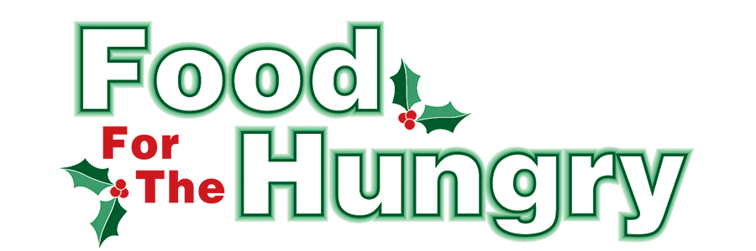

PRESS RELEASE
Contact Olivia Greenich Stern
Food For The Hungry Marketing Director
(330) 260-4059
oligreenich@gmail.com
August 11, 2023
FOR IMMEDIATE RELEASE

HEADLINE: Food For The Hungry collaborates with Knox County Foundation

MOUNT VERNON, Ohio — Food For The Hungry was featured in the Knox County Foundation's Annual Report. The Foundation was a major supporter of the 2022 FFTH Winter Drive, donating $25,000 to the drive. Through a recent collaboration effort from the Foundation to partner and invest in food initiatives, good work is being done to eliminate hunger in Knox County.

The article in the report, Knox County Foundation Leads New Food Access Initiative, reads,
“In an effort to streamline collaboration and coordination among food pantries and food access providers in the county, the Knox County Foundation unveiled a unique grantmaking partnership with Food For The Hungry as well as a new collaboration with the Knox County Food Council and all organizations addressing food insecurity issues in Knox County.
Presented at a fall luncheon, the Foundation and Food For The Hungry introduced a new model for expanded and more accessible funding. Both organizations will be utilizing a ‘Strengthening Our Pantries’ scorecard when reviewing grant applications and will be working together to determine funding allocations throughout 2023. Knox County Foundation will consider larger requests from pantries while Food For The Hungry will consider smaller requests, as well as all requests for food purchases. To facilitate this process, the Foundation made a grant of $25,000 to Food For The Hungry as part of its annual drive in 2022. ‘Knox County has a surplus of riches when it comes to individuals and organizations working to reduce food insecurity in our communities,’ said Lisa Lloyd, Program Director at Knox County Foundation. ‘This new initiative simply offers some additional coordination and collaboration within an already successful paradigm.’ Austin Swallow, Chair of the Food for the Hungry Board, added, ‘We are extremely grateful for the support and leadership of the Knox County Foundation and for all of the Foundation’s donors and partners who make projects like this possible.’
In addition to the grantmaking partnership, both organizations are encouraging a countywide network of pantries and organizations focused on helping feed those in need in Knox County. The hope is that this network will allow organizations to share ideas, best practices, and resources to help meet needs in the most effective and efficient manner possible. The long-term goal of the new coalition is to allow local pantries and partners to identify and develop additional ways of reducing food insecurity through collaboration. The Knox County Food Council is currently overseeing these efforts and is exploring potential opportunities such as shared warehouse space, strategic cooling and refrigeration locations, and even coordinated transportation and delivery services.
‘It is rewarding to see the community come together collaboratively like this,’ said Lloyd. ‘Knox County Foundation may be the catalyst, but the real work is being done every day on the ground by this coalition of food pantries and community partners. These are the kinds of charitable investments that really do improve the quality of life for our friends and neighbors.’”

See the article and the full Knox County Foundation 2022 Annual Report at this link:
https://knoxcf.org/.../2023/07/KCF_AnnualReport2022_v6.pdf

If you would like to learn more about the Foundation’s food access efforts or how you can support projects such as this, contact Lisa Lloyd at lisa@knoxcf.org or 740-392-3270.

Food For The Hungry has great anticipation for its continued collaboration with Knox County Foundation. Through this partnership, the goal of decreasing food insecurity in Knox County is sure to be achieved.

Find more information on FFTH, photos, radio interviews, videos, press releases, and more at FoodForTheHungryCares.org.

Food For The Hungry: Working together to care for our neighbors.
###

