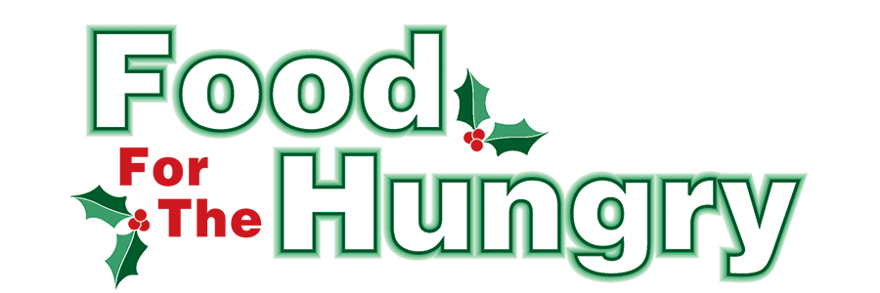

PRESS RELEASE
Contact Olivia Greenich Stern
Food For The Hungry Digital Content & Marketing Director
(330) 260-4059
oligreenich@gmail.com
NOV 13, 2023
FOR IMMEDIATE RELEASE

HEADLINE: The Psi Iota Xi Knox County Elementary School Drive kicks off Nov. 13
MOUNT VERNON — The 2023 Psi Iota Xi Knox County Elementary School Drive is underway with the help of Psi Iota Xi Sorority. All donations will benefit the 42nd annual Food For The Hungry Drive.
Mount Vernon area classrooms including The Knox Learning Center and 6th Grade Mount Vernon Middle School, as well as Centerburg, Danville, East Knox, and Fredericktown elementary schools, will join the sorority’s collection efforts, and each classroom will be supplied with collection boxes. Donations can be made from Monday, Nov. 13 through Friday, Nov. 17. The Top 10 items needed for our local pantries include Canned meat, Beef stew/hearty soup, Pasta, pasta sauce, instant potatoes, instant rice, Hot/cold cereal, peanut butter, canned fruit & vegetables.
Though non-food donations are welcome, cash donations are encouraged because $1 donated is equivalent to $4.89 of buying power through the Mid-Ohio Collective. Checks should be made payable to Food For The Hungry. All donations collected in each school will stay in the community in which they were donated. These students are asked to demonstrate the idea that no one is too young to make a difference and that the community is better when we work together!
As in the past, the classroom in each participating school that contributes the highest number of food items per student will be treated to a pizza party sponsored by Psi Iota Xi.
The top donor from each school will be honored in the Food For The Hungry broadcast at the Knox County Memorial Building on Friday, Dec. 8. The students will be recognized on our live video stream at www.mvnu.tv, as well as on 100.9 FM and 13WMVO, with reports given on WNZR and 93.7 the Super Q.
Follow FFTH on Facebook (@FoodForTheHungryKnoxCounty) and Instagram (@FFTHCares) to stay up to date on all things FFTH. Get involved by attending events, donating, volunteering, or even hosting your own event for FFTH! If you are hosting an event, make sure to fill out the Community Event Form on the FFTH website.

To learn more about FFTH, donate, or find photos, videos, and more, visit www.FoodForTheHungryCares.org. To volunteer with FFTH, call or text Lisa Mazarri at 740-398-0569. The 2023 FFTH Live Broadcast will take place on Friday, Dec. 8 at the Memorial Theater inside the Knox Memorial. This is a Knox County tradition you won’t want to miss!

Food For The Hungry—Working together to care for our neighbors.
###

