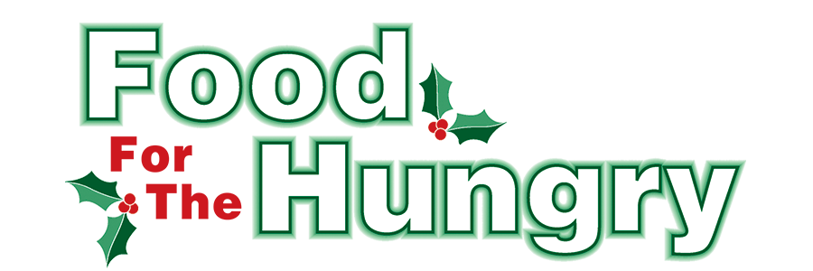

PRESS RELEASE
Contact Olivia Greenich Stern
Food For The Hungry Digital Content & Marketing Director
(330) 260-4059
contact@foodforthehungrycares.org
NOV 20, 2025
FOR IMMEDIATE RELEASE

HEADLINE: Knox County High Schools support Food For The Hungry
MOUNT VERNON — This year’s Knox County High School Drive competition will take place from November 24 - December 5, 2025. All donations will benefit the 44th annual Food For The Hungry Drive. The 2025 FFTH Drive Goal is $340,000, and as much non-perishable food as possible.
All Knox County High Schools are encouraged to join in the efforts to support FFTH. Donations can be made from Monday, November 24 to Friday, December 5. The Top Five items needed for local pantries are Canned Fruit/Vegetables, Soup (pop-top cans or packages preferred), Canned Meals (ravioli, Spaghetti-Os, and the like), Baked Beans, and Canned Meat. While food donations are always welcome, cash donations are encouraged as $1.00 donated is equivalent to $4.56 of buying power through the Mid-Ohio Collective. Checks should be made payable to Food For The Hungry.

Though the official competition begins on November 24, some schools have already started their efforts to support FFTH. Knox County Career Center hosted a car show in May, sold FFTH-inspired t-shirts and sweatshirts in early November, and has a number of other student-led collections ongoing. East Knox High Schoolers have already raised over $600 with their “Penny Wars.”

These students demonstrate the idea that no one is too young to make a difference and that the community is better when we work together! The classroom in each participating school that contributes the highest number of food items per student will be treated to a pizza party.

The top donor from each school will be honored in the Food For The Hungry broadcast at the Knox County Memorial Building on Friday, Dec. 12. The students will be recognized on our live video streams at www.mvnu.tv and FFTH’s YouTube channel, as well as on 100.9 FM and 93.7 FM HD2 - WMVO, with reports given on 90.9 FM WNZR and 93.7 FM the Super Q.
Follow FFTH on Facebook (@FoodForTheHungryKnoxCounty) and Instagram (@FFTHCares) to stay up to date on all things FFTH. Get involved by attending events, donating, volunteering, or even hosting your own event for FFTH! If you are hosting an event or collection, make sure to fill out the Community Event/Collection Form on the FFTH website.

To learn more about FFTH, donate, or find photos, videos, and more, visit www.FoodForTheHungryCares.org. To volunteer with FFTH, fill out the volunteer form on FFTH’s website.
The 2025 FFTH Live Broadcast will take place on Friday, Dec. 12 at the Memorial Theater inside the Knox Memorial. This is a Knox County tradition you won’t want to miss!

Food For The Hungry—Working together to care for our neighbors.
###

Photo Captions
1. East Knox High School Students pose with their “Penny Wars” containers.
2. KCCC Staff and Students interview during 2024 FFTH LIVE

