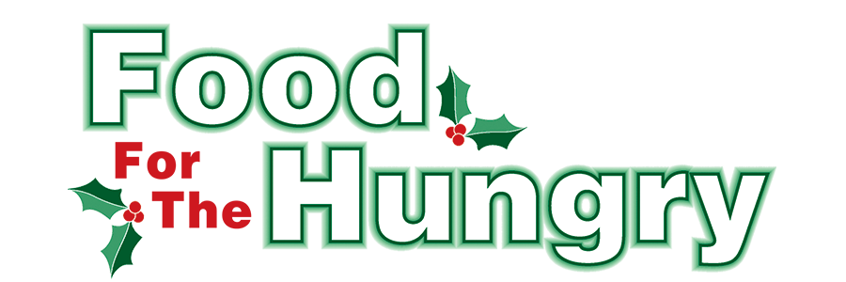

PRESS RELEASE
Contact Olivia Greenich Stern
Food For The Hungry Digital Content and Marketing Director
(330) 260-4059
contact@foodforthehungrycares.org
NOV 7, 2025
FOR RELEASE ON NOV 7.

HEADLINE: Food For The Hungry Kicks Off Drive Season with Goal of $340,000

MOUNT VERNON, Ohio—The annual Food For The Hungry Drive officially kicked off on Friday morning, Nov. 7, as a community-wide effort to raise food and funds for Interchurch Social Services, The Salvation Army, and other organizations throughout the county with food assistance initiatives. In Food For The Hungry’s (FFTH) 44th year of helping the community, it has established a financial Drive Goal of $340,000 and hopes to collect as many non-perishable food items as the community can donate.

Food for the Hungry is a nonprofit organization focused on providing food and financial support to entities striving to reduce hunger in Knox County, Ohio. To accomplish this mission, there is a food and money drive made up of multiple events and collections culminating in a one-day simulcast (broadcast online and via the radio) on the second Friday of December. The 2025 Drive will take place on December 12, from 9 A.M. to 5 P.M. The food and funds collected by FFTH are distributed to local agencies that work firsthand with those in need of food in Knox County.
It is no mystery that inflation and government cuts to food assistance funding have altered the lives of countless people. While many people feel the weight of their grocery bills getting higher, the number of people who cannot afford any food to feed their families or themselves is rising. From a survey taken in 2022, the Knox County Food Council estimated that more than 14,000 individuals in Knox County experience food insecurity. That number has likely grown. In 2022, Interchurch Social Services of Knox County (ISS) served up to 200 families a month. In 2025, ISS served almost 700 families a month. The Mid-Ohio Food Collective (formerly known as Mid-Ohio Food Bank) is also feeling pressure. Mid-Ohio Food Collective is a major source of food for the agencies that are supported through FFTH. The buying power of $1 at the Mid-Ohio Food Collective has dropped to $4.56 - half of what it was several years ago.
Despite the decline in the buying power of $1, FFTH is confident that those less fortunate in this community can continue to count on its generous donors to address food insecurity and to disrupt the poverty cycle in Knox County. A food pantry can still use a single $1 to buy $4.56 worth of food from Mid-Ohio Food Collective. That means a couple of dollars could provide dinner for an entire family. Therefore, no effort to support the FFTH mission is too small! Fundraising events for previous drives have ranged from county-wide Service Club competitions to Middle School girls selling homemade bracelets. You can make a difference by participating in the 2025 FFTH Drive!
The people of Knox County exceeded the Drive Goal last year and raised $342.459.11 and 11 truckloads of food.
Funds from the 2024 FFTH Drive were allocated for this year’s Summer and Winter Grants. In June this year, a total of $31,250 in grants was awarded to 16 different Knox County organizations, prioritizing projects that focused on feeding children who rely on school meals throughout the school year. Winter Grants will enable local food pantries and hot meals to provide food to those in need through the 2025-2026 winter. Grant recipients will be announced on November 20, 2025. In a collaborative effort with Knox County Foundation and ISS, FFTH helped host a pop-up food pantry on November 1, serving over 200 Knox County families in need.
As always, the largest portion of the Drive Goal (68%) and all food collected goes to FFTH community partners, Interchurch Social Services and The Salvation Army in Mount Vernon. The remaining funds will be awarded in 2026 through both the Summer Grants (8%) and Winter Grants (14%), as well as a small portion for organizational expenses (10%).
A way to contribute to the 2025 Food For The Hungry goal is by donating at local events or community collections that support FFTH. Some upcoming events include:Turkey Trot 5K - Thursday, November 27, 8 AM registration, 9 AM race start.
Mount Vernon Holiday Parade and Events - Sunday, November 30, 4-7 PM.
Knox County Park District’s Fire and Ice - Saturday, December 6.
FFTH LIVE and Drive Day - Friday, December 12, 8 AM-5 PM.
Snowflake Gala, Saturday, December 13, 6 PM.

For more information on local events and collections, visit www.FoodForTheHungryCares.org.

Thank you to every individual and organization in Knox County who continuously believe in Food For The Hungry's vision and the desire to better our community.

To celebrate the kick-off, follow FFTH on Facebook (@FoodForTheHungryKnoxCounty) and Instagram (@FFTHCares) to stay up to date on all things FFTH. Get involved by attending events, donating, volunteering, or even hosting your own event for FFTH! If you are hosting an event, make sure to fill out the Community Event Form on the FFTH website.

To learn more about FFTH, donate, or find photos, videos, and more, visit www.FoodForTheHungryCares.org. To volunteer with FFTH, call or text Kathy Brechler at (740)-398-2408 or email at Director@FoodForTheHungryCares.org.
The 2025 FFTH Live Broadcast will take place on Friday, Dec. 12, at the Memorial Theater inside the Knox Memorial. This is a Knox County tradition you won’t want to miss!

Food For The Hungry—Working together to care for our neighbors.
###

