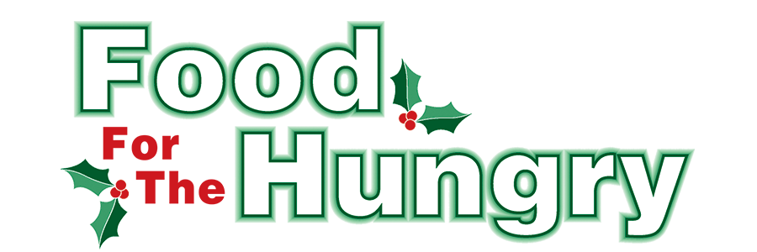

PRESS RELEASE
Contact Olivia Greenich Stern
Food For The Hungry Digital Content and Marketing Director
(330) 260-4059
contact@foodforthehungrycares.org
NOV 18, 2025
For Immediate Release

HEADLINE: Food For The Hungry Awards $53,500 in Winter Grants

MOUNT VERNON, OHIO—The annual Food For The Hungry Drive officially kicked off on Nov. 7, as a community-wide effort to raise food and funds for Interchurch Social Services, The Salvation Army, and other organizations throughout the county with food assistance initiatives. In Food For The Hungry’s (FFTH) 44th year of helping the community, it has established a financial Drive Goal of $340,000 and hopes to collect as many non-perishable food items as the community can donate.

Food for the Hungry is a nonprofit organization focused on providing food and financial support to entities striving to reduce hunger in Knox County. To accomplish this mission, there is a food and money drive consisting of multiple events culminating in a one-day simulcast (broadcast online and via the radio) on the second Friday of December. The 2025 Drive will take place on December 12, from 9 A.M. to 5 P.M..
Each year, FFTH awards Winter Grants that enable Knox County organizations to provide food to those in need. To assess the community's needs, FFTH opened its Winter Grant Application from October 1-31 and received an exceptional response. Each organization was able to express its particular needs. Funds from the 2024 FFTH Drive were allocated for this year's Winter Grants; however, the FFTH Grants Committee faced a challenge as the need shared by applicants was greater than the budgeted amount for Winter Grants. Understanding the growing need in our community, the FFTH Grants Committee decided to use reserve funds from previous years when the FFTH Campaign Goals were met and exceeded. After careful review of the applications by the FFTH Grant Committee, FFTH is honored to award a total of $53,500 in grant funds to 22 different organizations! The grant recipients are as follows:
ACTS Food Pantry - $3,000
Afterglow Christian Mission House - $1,000
Alcohol & Drug Freedom Center Knox County - $1,500
Central Christian Church Food Pantry - $3,500
CHOMP Free Fresh Produce Market - $2,500
Church on the Rise Food Pantry - $3,500
Covenant Church Food Pantry - $3,500
East Knox Schools/First Church of the Nazarene Weekend Meals for Students - $3,000
Escape Zone - $2,500
First Church of the Nazarene/Foster Ministry Center Food Pantry & Hot Meal - $6,000
First Presbyterian Church Hot Meal - $2,500
Fredericktown Senior Activity Center - $1,500
Gay Street United Methodist Church Hot Meals - $2,500
Jacqueline McCalla-Cordle Children’s Fund (Spring Break distribution) - $1,500
Knox County Career Center Food Pantry - $2,500
Knox County Head Start School Break Food Boxes - $3,000
Knox County Task Force For Older Adults Holiday Meals for Homebound Seniors - $1,500
LifePointe Church Backpacks of Hope - $3,000
Mount Vernon Association of Police Chaplains First Response Family Support - $1,000
Saint Paul’s Episcopal Church Sunday Sanctuary Hot Meal - $1,500
TouchPointe Marriage and Family Resources - $1,500
Winter Sanctuary Emergency Homeless Shelter - $1,500
The recipients will use their grants for food initiatives that range from food pantries to weekend meal assistance for students. Each recipient will be recognized during the 2025 FFTH Live Broadcast that will take place on Friday, Dec. 12, from 9 A.M. to 5 P.M. at the Memorial Theater inside the Knox Memorial. Grant recipients will be approached shortly after Thanksgiving about an interview on the broadcast. FFTH Live will be available on 100.9 FM and 93.7 HD2 - WMVO, with video streams at www.mvnu.tv and the FFTH YouTube channel. Updates will be given throughout the day on 90.9 FM WNZR, 93.7 FM, The Super Q, and FFTH social media. This is a Knox County tradition you won’t want to miss!

Follow FFTH on Facebook (@FoodForTheHungryKnoxCounty) and Instagram (@FFTHCares) to stay up to date on all things FFTH. Get involved by attending events, donating, volunteering, or even hosting your own event for FFTH! A Community Collection/Event Form and a Volunteer Form can be found on the FFTH website.

To learn more about FFTH, donate, or find photos, videos, and more, visit www.FoodForTheHungryCares.org.
Food For The Hungry—Working together to care for our neighbors.
###

