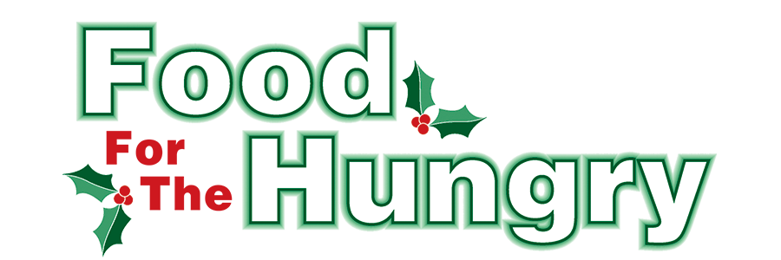

PRESS RELEASE
Contact Olivia Greenich Stern
Food For The Hungry Digital Content & Marketing Director
(330) 260-4059
Contact@FoodForTheHungryCares.org
December 8, 2025
FOR IMMEDIATE RELEASE
HEADLINE: Food For The Hungry Announces Major Grant for Salvation Army of Mount Vernon
MOUNT VERNON, OH— Food For The Hungry (FFTH) is proud to announce that the Grants Committee has approved a major investment in community food access during this 2025 funding cycle. The largest award of the season — $10,000 grant to The Salvation Army of Mount Vernon — will support the purchase of a new refrigerator and freezer for the organization’s renovated and expanded Choice Pantry. The Salvation Army service center, originally built in 1993, is undergoing a significant update to better meet today’s needs.

“Choice pantries are now the preferred model nationwide,” said FFTH President Austin Swallow. “Allowing individuals and families to ‘shop’ for foods they will use preserves dignity and ensures no food goes to waste.” The new refrigeration units will allow the pantry to provide fresh produce, milk, eggs, and a wider variety of frozen items.
FFTH awarded $5,000 for a refrigerator and $5,000 for a freezer, using designated “set-aside” funds from previous FFTH Drives when donations exceeded the drive goals. FFTH made a similar gift to Interchurch Social Services in 2023 when they needed to purchase a new refrigerator.
The Salvation Army’s service to Knox County residents remains essential. Between September 1, 2024 and August 31, 2025, the Salvation Army provided:
- 19,620 meals through pantry assistance — serving a total of 2,936 people.
- 5,945 meals and snacks to youth through Hot Meals, After-School, and Summer programs.
- 4,316 hot meals to community members outside of youth programs.
- A total of $36,466.27 in rent/utility aid to 157 families.
- 336 backpacks filled with school supplies were distributed to local students.
- Toys, clothing, and food were provided to 737 children through the 2024 Christmas Assistance Program.
- After-school care for 35 students.
- Summer day camp for 26 students.
The Salvation Army in Mount Vernon is set to open its new state-of-the-art childcare facility in January 2026. The center will provide quality and affordable childcare to 112 children.
This special $10,000 FFTH grant and the ongoing partnership between FFTH, The Salvation Army, and Interchurch Social Services reflect one shared mission: Working Together To Care For Our Neighbors.
Food For The Hungry of Knox County is continuing to support this community as it strives to collect $340,000 and as much non-perishable food as possible for its 2025 campaign. 68% of the Drive Goal and all food collected goes to FFTH community partners - Interchurch Social Services and The Salvation Army. The remaining funds will be awarded in 2026 through both Summer Grants (8%) and Winter Grants (14%), as well as a small portion set aside for organizational expenses (10%). FFTH just awarded a total of $55,000 in 2025 Winter Grants to 23 local organizations - the highest amount granted in FFTH’s history.
None of this would be possible without donor support. Thank you, Knox County, for making a lasting impact.
Follow FFTH on Facebook (@FoodForTheHungryKnoxCounty) and Instagram (@FFTHCares) to stay up to date on all things FFTH. Get involved by attending events, donating, volunteering, or even hosting your own event for FFTH! If you are hosting an event or collection, make sure to fill out the Community Event/Collection Form on the FFTH website.

To learn more about FFTH, donate, or find photos, videos, and more, visit www.FoodForTheHungryCares.org. To volunteer with FFTH, fill out the volunteer form on FFTH’s website. The Food For The Hungry Live Broadcast and Drive Day is December 12 from 9:00 AM–5:00 PM. FFTH Live will be available for live stream from the Memorial Theater at Knox Memorial on www.mvnu.tv and the Food For The Hungry of Knox County YouTube channel. The broadcast can also be heard live on 100.9 FM, 93.7 HD2 WMVO, the WMVO listening APP, and WMVO.com. Live updates will also be available throughout the day on 90.9 FM WNZR and 93.7 The Super Q. FFTH Live and Drive Day is a celebration of Knox County! This is a Knox County tradition you won’t want to miss!

Food For The Hungry—Working together to care for our neighbors.
###

Photo Caption: FFTH President Austin Swallow and Captain Christine Moretz of The Salvation Army stand together at the Experience Mount Vernon Holiday Parade.

