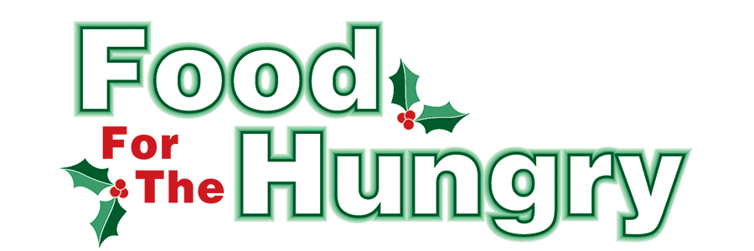

PRESS RELEASE
Contact Olivia Greenich-Stern
Food For The Hungry Marketing Director
(330) 260-4059
oligreenich@gmail.com
October 11, 2023
FOR IMMEDIATE RELEASE

HEADLINE: Veteran’s Day Concert to Benefit Food For The Hungry

MOUNT VERNON, Ohio — The Woodward Opera House together with Mount Vernon Dental proudly present “A Veteran’s Day Tribute” by the Central Ohio Brass band. The concert is located in the main theater of the historic Woodward Opera House on November 11th.
In addition to honoring those who have bravely served this country, proceeds from this concert will also benefit local charity Food For The Hungry. General admission tickets will be $15 and are available online or at the door the night of the concert.
Founded in 1989 by Dr. Paul Droste as the Ohio Collegiate Brass Band, the Central Ohio Brass Band is a 503c non-profit community band that is part of the North American Brass Band Association. Throughout the year, COBB enjoys a vigorous performance schedule, frequently playing at church functions, community festivals, and schools in order to promote life-long learning as well as to foster the brass band tradition in the United States.
COBB competes in the North American Brass Band Association (NABBA) Championships, having earned 1st place in the 1st Section five times (2007, 2009, 2010, 2011, 2012). In addition to the NABBA Championships, COBB has performed at the Butlin Mineworkers' Open National Brass Band Festival in the United Kingdom, the Great American Brass Band Festival, the US Open Brass Band Championships, the Dublin Festival of Brass, and the International Trombone Festival.
For tickets and additional information visit TheWoodward.org
Food For The Hungry: Working together to care for our neighbors.
###

