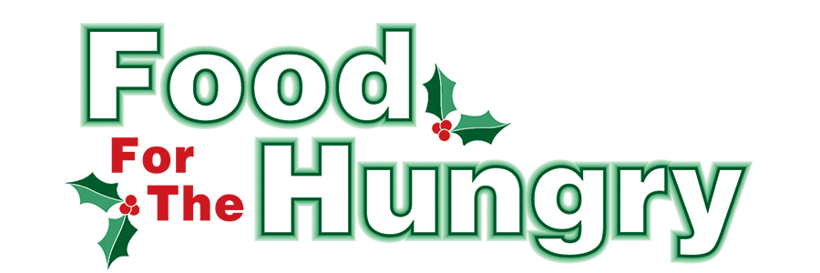

PRESS RELEASE
Contact Olivia Greenich Stern
Food For The Hungry Digital Content & Marketing Director
(330) 260-4059
oligreenich@gmail.com
December 6, 2023
FOR IMMEDIATE RELEASE

HEADLINE: Apple Valley presents the Festival of Trees to support Food For The Hungry
HOWARD — The Apple Valley Property Owners Association is hosting a Festival of Trees at the Floral Valley Community Center, from December 2 through December 31. The public is invited to come and enjoy the decorations and bring donations for Food For The Hungry.
Food can be dropped off in the Floral Valley Lobby. There are envelopes available for cash or check donations. The envelopes can be put into a lock box anchored to the wall. All donations will benefit Danville Interchurch Social Services.
The Floral Valley Community Center is located at 850 Crestrose Drive in Howard.
Festival of Trees is open:
Mondays – Fridays from 2 pm – 7 pm
Saturdays from 9 am – 7 pm
Sundays 12 pm -7 pm
For more information, call Floral Valley Community Center at 740-397-1027 or call Audrey at 740-397-1962.
Follow FFTH on Facebook (@FoodForTheHungryKnoxCounty) and Instagram (@FFTHCares) to stay current on all things FFTH. Get involved by attending events, donating, volunteering, or even hosting your own event for FFTH! If you are hosting an event, make sure to fill out the Community Event Form on the FFTH website.

To learn more about FFTH, donate, or find photos, videos, and more, visit www.FoodForTheHungryCares.org. To volunteer with FFTH, call or text Lisa Mazarri at 740-398-0569. Food For The Hungry Live begins on Friday, Dec. 8 at 9:00 a.m. and continues until 4:00 p.m. FFTH Live’s audio will be available on 100.9 FM and 93.7 FM HD2 WMVO, WMVO.com, and the WMVO App. Video will be available at www.mvnu.tv and on the FFTH Facebook page. Updates will be given throughout the day on 90.9 FM WNZR, 93.7 FM The Super Q WQIO, and FFTH social media. FFTH Live will air from the Memorial Theater in Knox Memorial on East High Street in Mount Vernon. This is a Knox County tradition you won’t want to miss!

Food For The Hungry—Working together to care for our neighbors.
###

