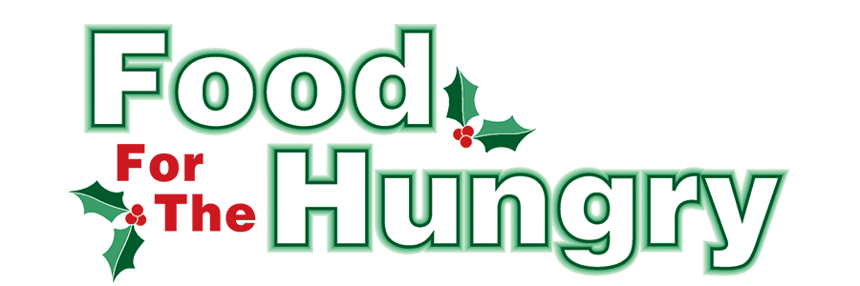

PRESS RELEASE
Contact Olivia Greenich Stern
Food For The Hungry Digital Content & Marketing Director
(330) 260-4059
oligreenich@gmail.com
NOV 20, 2023
FOR IMMEDIATE RELEASE

HEADLINE: 13th Annual Turkey Trot on Thanksgiving Morning in support of Food For The Hungry!
MOUNT VERNON — The 13th Annual Turkey Trot 5K Run/Walk will take place on Thanksgiving morning, Nov. 23, on the campus of Mount Vernon Nazarene University. WeRunMV will be hosting this event. This event is free—instead of charging for participation, monetary and non-perishable food donations will be collected for Food For The Hungry of Knox County.
For every $1.00 raised, community partner agencies can purchase $4.89 worth of food from the Mid-Ohio Food Collective (formally the Mid-Ohio Food Bank).
Registration will begin at 8 AM. and the race will start at 9 AM. Please gather at least five minutes prior to the start time. Participants can use the R.R. Hodges Chapel/Auditorium on the Mount Vernon Nazarene Campus for parking. The race will begin and end at the entrance of the Chapel. Restrooms and the Chapel foyer will be open to the public.
The Turkey Trot is designed for runners and walkers of all ages. This family fun event is an exciting start to your Thanksgiving Day. This event is open to everyone and canines are welcome!
For more information on the Turkey Trot, contact Scott Burgess at 740-326-0750.
Follow FFTH on Facebook (@FoodForTheHungryKnoxCounty) and Instagram (@FFTHCares) to stay up to date on all things FFTH. Get involved by attending events, donating, volunteering, or even hosting your own event for FFTH! If you are hosting an event, make sure to fill out the Community Event Form on the FFTH website.
To learn more about FFTH, donate, or find photos, videos, and more, visit www.FoodForTheHungryCares.org. To volunteer with FFTH, call or text Lisa Mazarri at 740-398-0569. The 2023 FFTH Live Broadcast will take place on Friday, Dec. 8 at the Memorial Theater inside the Knox Memorial. This is a Knox County tradition you won’t want to miss!

Food For The Hungry—Working together to care for our neighbors.
###

