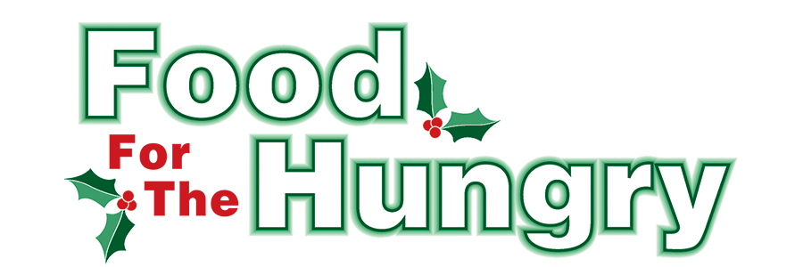

FOR IMMEDIATE RELEASE
Contact Olivia Greenich Stern
Food For The Hungry Digital Content and Marketing Director
(330) 260-4059
oligreenich@gmail.com
NOV 6, 2023
FOR IMMEDIATE RELEASE

HEADLINE: Knox Public Library marks 35 years of supporting Food For The Hungry

MOUNT VERNON — 2023 marks the 35th year of The Knox County Public Library campaigning for Food For The Hungry. As this tradition continues, the Libraries of Knox County will be collection points for food donations from November 6 - December 2. Library branches participating include Danville Public Library, Fredericktown Community Library, Gambier Community Library, and the Public Library of Mount Vernon and Knox County. The libraries will be collecting non-perishable food items, money, and care items/food for dogs and cats for the Humane Society.

The top ten food items needed are peanut butter, canned meat (chicken, tuna), beef stew/hearty soups, canned pasta, boxed dinners (Hamburger Helper), spaghetti/spaghetti sauce, cereal (hot and cold), baked beans/kidney/chili beans, noodles/instant rice/potatoes, and canned fruits and vegetables. Cans that can be opened without a can opener (pop top) are best.

Non-perishable items that are at or near their expiration dates, damaged, or in compromised containers will not be accepted. All collected food and money will be given to the 2023 Food For The Hungry Drive. Donations from each community will stay in that local community.
Follow FFTH on Facebook (@FoodForTheHungryKnoxCounty) and Instagram (@FFTHCares) to stay up to date on all things FFTH. Get involved by attending events, donating, volunteering, or even hosting your own event for FFTH! If you are hosting an event, make sure to fill out the Community Event Form on the FFTH website.

To learn more about FFTH, donate, or find photos, videos, and more, visit www.FoodForTheHungryCares.org. To volunteer with FFTH, call or text Lisa Mazarri at 740-398-0569. The 2023 FFTH Live Broadcast will take place on Friday, Dec. 8 at the Memorial Theater inside the Knox Memorial. This is a Knox County tradition you won’t want to miss!

Food For The Hungry—Working together to care for our neighbors.
###

