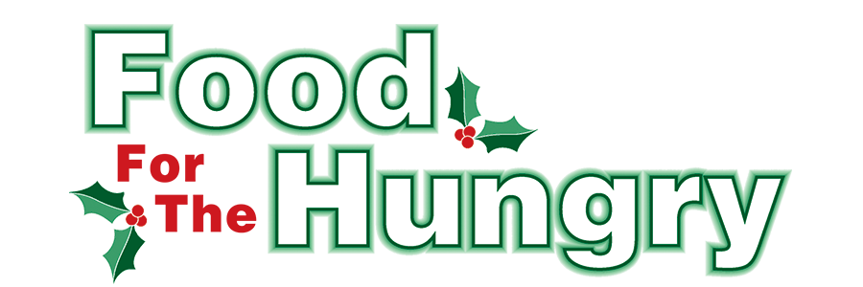

PRESS RELEASE
Contact Olivia Greenich Stern
Food For The Hungry Digital Content & Marketing Director
(330) 260-4059
contact@foodforthehungrycares.org
May 29, 2024
FOR IMMEDIATE RELEASE

HEADLINE: Food For The Hungry grants $31,250 for Summer Food Programs

MOUNT VERNON, Ohio—Food For The Hungry celebrates its fifth year of summer grants to help organizations throughout Knox County eliminate food insecurity during the summer. Since starting the summer grant program in 2020, money for the grants came from funds that exceeded the Drive Goal. After four years of waiting to see if support exceeded the goals to fund summer grants, FFTH decided to prioritize summer grants to ensure food assistance programs were supported throughout the entire year. To sustain summer grant opportunities and account for inflation, FFTH set a larger goal of $330,000 in 2024, and it was no surprise when the people of Knox County exceeded that goal by raising $342,459.11. Through the summer grants, FFTH continues to honor the wishes of its donors to support their local community year-round.

While these are uncertain times for food banks and hot meals in Ohio, Food For The Hungry President Austin Swallow offers encouragement to Knox County. “At Food For The Hungry, we remain unwavering in our commitment to support local food initiatives and our community, especially in these challenging times. Despite the announced financial cuts which may impact our food pantry partners here in Knox County and throughout Ohio, we are dedicated to ensuring that those who are most vulnerable in Knox County continue to receive the food and resources they need. We recognize the increasing demand for assistance and are focused on finding innovative solutions to maximize the impact of the donations you have entrusted to our care,” states Swallow. “As the year goes on, FFTH will continue to monitor the situation and will stand firm in our resolve to help our neighbors, no matter the challenges we may face. Together, we will make sure that food insecurity does not define the future of our county.”
With this mission at the forefront of their minds, the FFTH grant committee prioritized food initiatives that supplement food for children and teens whose primary source of food is the free or reduced breakfast and lunch given to them during the school year. Other food programs were also encouraged to apply and there was a large response to the grant application.

After great consideration of the applications, FFTH has chosen 16 organizations as summer grant recipients. FFTH is honored to award a total of $31,250 in grant funds to these local organizations:

Alcohol and Drug Freedom Center of Knox County - Emergency Food Assistance
- $1,000.00
Central Christian Church Food Pantry
- $2,500.00
Cornerstone Community Church Peacemeals
- $2,000.00
East Knox School District and First Church of the Nazarene - Food For Students
- $3,000.00
Escape Zone - Friday Night Meals for 75+ Students, Age 10-18
- $2,000.00
First Church of the Nazarene - Father's Table/Father's Pantry
- $3,000.00
Fredericktown Senior Activity Center - Well-balanced Dinners for Seniors
- $500.00
First Presbyterian Church of Mount Vernon Hotmeals
- $2,000.00
Interchurch Social Services - School Pantry Program
- $4,000.00
Jacque Cordle Children’s Fund - Food Assistance for Children
- $750.00
Joy of Living Camp - Meals for Knox County Campers
- $1,000.00
Martinsburg Activity Center - Children’s Summer Lunch Program
- $2,000.00
MV SDA Hill Church - Knox County Hot Meals
- $2,000.00
Sharing Shed at Millwood Church of Christ
- $1,000.00
The Church On The Rise Food Pantry Ministry
- $2,500.00
The Salvation Army - Breakfast, Lunch, and Snacks for 40 Day Campers
- $2,000.00

Thank you to every individual in Knox County who continuously believes in the vision of Food For The Hungry and the desire to better your community. The generosity displayed each year makes grants like these possible!

To learn more, donate, or find photos, videos, and radio interviews from the 2024 Drive, visit www.FoodForTheHungryCares.org.

Food For The Hungry—Working Together To Care For Our Neighbors.
###

Photo Caption: Volunteers prepare hot meals at Cornerstone Community Church in Fredericktown, a 2024 FFTH Summer Grant Recipient.

