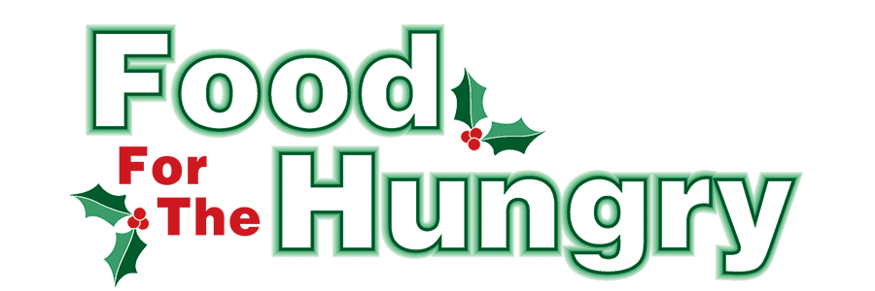

PRESS RELEASE
Contact Olivia Greenich Stern
Food For The Hungry Marketing Director
(330) 260-4059
oligreenich@gmail.com
June 8, 2023
FOR IMMEDIATE RELEASE

HEADLINE: Food For The Hungry grants $25,000 for Summer Food Programs

MOUNT VERNON, Ohio—Food For The Hungry opened a special Summer Grant process to help organizations throughout Knox County eliminate the food gap for children and teens during Summer vacation. Hundreds of Knox County minors’ primary source of food is the free or reduced breakfast and lunch given to them at school. There is a significant need for supplemental food throughout their Summer Break. Because of the overwhelming generosity of Knox Countians during the 2022 FFTH Drive, reserve funds were set aside for Summer Grants. Through the Summer Grants, FFTH continues to honor the wishes of our donors to support their local community year-round. FFTH is honored to award a total of $25,000 in grant funds to these local organizations:

Say A Prayer Ministries/InJoy Food Pantry—$2,000
Say A Prayer Ministries is a church that has a food pantry called InJoy Food Pantry located in Martinsburg. Say A Prayer Ministries can also help families with emergency needs between outreach days.

Martinsburg Activity Center—$2,000
Martinsburg Activity Center, in partnership with InJoy Food Pantry, is providing on-site daily lunches to students throughout the Summer.

Mobility Management—$2,000
Mobility Management provides transportation to community resources, including food pantries, local farmer’s markets, and hot meals. Its goal is to eliminate transportation barriers that keep people from accessing the food they need.

Church on the Rise Food Pantry—$2,000
Church on the Rise serves food and non-food items to people in the community in need through a monthly giveaway. Emergency food is also provided at least 10 times a month for those in urgent need.

Central Christian Food Pantry—$3,000
Central Christian Food Pantry provides food to families in Knox County and provides personal food packages for children during the Summer months.

Covenant Church Food Pantry—$2,000
Covenant Church provides food for those in need in Knox County. They provide a family of four with enough food for 2 weeks. Extra food is used to reach out to families with children during the Summer.

Jacqueline McCalla-Cordle Children’s Fund—$3,000
Jacqueline McCalla-Cordle Children’s Fund provides nutritious meals to qualified school children and families on reduced/free lunches. It has expanded its resources to meet the food insecurity of all residents in the Centerburg School District by opening a food pantry for weekly food distribution.

Fredericktown United Methodist Peacemeals—$3,000
Fredericktown United Methodist Church provides a weekly community hot meal called PeaceMeals. All meals are prepared and served by volunteers.

Lazarus Life Ministries—$2,000
Lazarus Life Ministries is a recovery program for men in Knox County. Lazarus Life hosts family weekend meals where families can come and visit the men in recovery.

Milwood Church of Christ Sharing Shed & Garden—$2,000
Millwood Church of Christ provides a free-standing sharing shed that is open 24 hours a day, 7 days a week. This shed has shelving for non-perishable food items and a refrigerator/freezer. There is also a garden that will provide fresh produce for the community. No paperwork is required, and neighbors are encouraged to take what they need and leave what they can.

The Escape Zone Youth Center—$2,000
The Escape Zone provides a safe, supervised place for children ages 10–18 to congregate. This Summer, volunteers will also be providing meals to any child who is in need of food at the various events, such as Friday night activities, Bible study, youth volleyball and other sports throughout the week.

Thank you to every individual in Knox County who continuously believes in the vision of Food For The Hungry, and the desire to better our community. The generosity displayed each year makes grants like these possible.

To learn more, donate, or find photos, videos, and radio interviews from the 2022 Drive, visit www.FoodForTheHungryCares.org.

Food For The Hungry—Working together to care for our neighbors.
###

