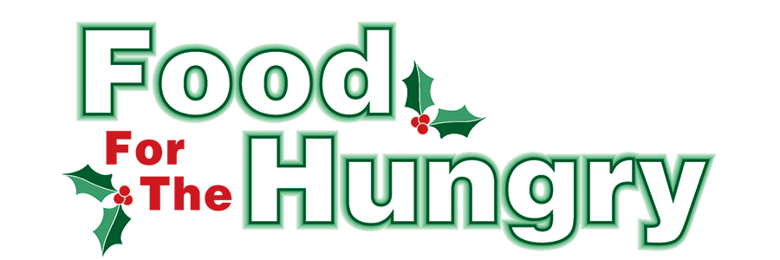

**PRESS RELEASE**

**Contact Olivia Greenich Stern  
Food For The Hungry Digital Content & Marketing Director  
(330) 260-4059  
oligreenich@gmail.com**

**NOV 20, 2024**

**FOR IMMEDIATE RELEASE**

**HEADLINE: 14th Annual Turkey Trot on Thanksgiving Morning in support of Food For The Hungry!**

**MOUNT VERNON —** The 14th Annual Turkey Trot 5K Run/Walk will take place on Thanksgiving morning, Nov. 28, on the campus of Mount Vernon Nazarene University. WeRunMV will be hosting this event. This event is free—instead of charging for participation, monetary and non-perishable food donations will be collected for Food For The Hungry of Knox County.

For every $1.00 raised, community partner agencies can purchase $4.56 worth of food from the Mid-Ohio Food Collective (formally the Mid-Ohio Food Bank).

Registration will begin at 8 AM. and the race will start at 9 AM. Please gather at least five minutes prior to the start time. Participants can use the R.R. Hodges Chapel/Auditorium on the Mount Vernon Nazarene Campus for parking. The race will begin and end at the entrance of the Chapel. Restrooms and the Chapel foyer will be open to the public.

The Turkey Trot is designed for runners and walkers of all ages. This family fun event is an exciting start to your Thanksgiving Day. The race is open to everyone and canines are welcome!

For more information on the Turkey Trot, contact Scott Burgess at 740-326-0750.

Follow FFTH on Facebook (@FoodForTheHungryKnoxCounty) and Instagram (@FFTHCares) to stay up to date on all things FFTH. Get involved by attending events, donating, volunteering, or even hosting your own event or collection for FFTH! If you are hosting an event/collection, make sure to fill out the Community Event Form on the FFTH website.

To learn more about FFTH, donate, or find photos, videos, and more, visit [www.FoodForTheHungryCares.org](http://www.foodforthehungrycares.org). To volunteer with FFTH, call or text Kathy Brechler at (740)-409-1866 or email Director@FoodForTheHungryCares.org.

FFTH LIVE begins on Friday, Dec. 13 at 9 A.M. and continues until 4 P.M. FFTH LIVE will be available on 100.9 FM and 93.7 HD2 - WMVO, with video stream at [www.mvnu.tv](http://www.mvnu.tv/) and the FFTH Facebook page. Updates will be given throughout the day on 90.9 WNZR, 93.7 The Super Q, and FFTH social media. FFTH LIVE will air from the Memorial Theater in Knox Memorial on East High Street in Mount Vernon.

This is a Knox County tradition you won’t want to miss!

***Food For The Hungry—Working together to care for our neighbors.***

###