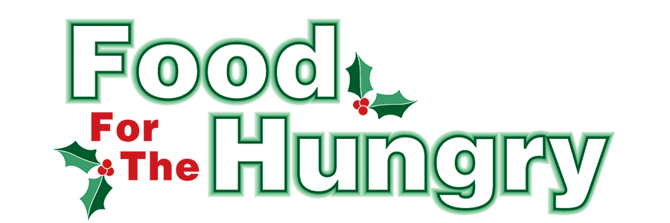

**PRESS RELEASE**

**Contact Olivia Greenich Stern  
Food For The Hungry Digital Content & Marketing Director  
(330) 260-4059  
oligreenich@gmail.com**

**NOV 13, 2024**

**FOR IMMEDIATE RELEASE**

**HEADLINE: The Psi Iota Xi Knox County Elementary School Drive kicks off Nov. 18**

MOUNT VERNON — The 2024 Psi Iota Xi Knox County Elementary School Drive starts Nov. 18 with the help of Psi Iota Xi Sorority. All donations will benefit the 43rd annual Food For The Hungry Drive.

Mount Vernon area classrooms including The Knox Learning Center and 6th Grade Mount Vernon Middle School, as well as Centerburg, Danville, East Knox, and Fredericktown elementary schools, will join the sorority’s collection efforts, and each classroom will be supplied with collection boxes. Donations can be made from Monday, Nov. 18 through Friday, Nov. 22. The Top 10 items needed for our local pantries include soup (pop-tops or packages), jelly, canned meals (ravioli, spaghettios, etc.), breakfast foods (cereal, oatmeal, pancake mix), canned fruit, canned vegetables, pasta/egg noodles, side dishes (boxed or packaged), peanut butter, and pasta sauce.

*Though non-food donations are welcome, cash donations are encouraged because $1 donated is equivalent to $4.56 of buying power through the Mid-Ohio Collective.* Checks should be made payable to **Food For The Hungry**. All donations collected in each school will stay in the community in which they were donated. These students are asked to demonstrate the idea that no one is too young to make a difference and that the community is better when we work together!

As in the past, the classroom in each participating school that contributes the highest number of food items per student will be treated to a pizza party sponsored by Psi Iota Xi.

The top donor from each school will be honored in the Food For The Hungry broadcast at the Knox County Memorial Building on Friday, Dec. 13. The students will be recognized on our live video stream at [www.mvnu.tv](http://www.mvnu.tv/), as well as on 100.9 FM and 93.7 HD2 - WMVO, with reports given on WNZR and 93.7 the Super Q.

Follow FFTH on Facebook (@FoodForTheHungryKnoxCounty) and Instagram (@FFTHCares) to stay up to date on all things FFTH. Get involved by attending events, donating, volunteering, or even hosting your own event for FFTH! If you are hosting an event or collection, make sure to fill out the Community Event/Collection Form on the FFTH website.

To learn more about FFTH, donate, or find photos, videos, and more, visit [www.FoodForTheHungryCares.org](http://www.foodforthehungrycares.org). To volunteer with FFTH, call or text Kathy Brechler at (740)-409-1866 or email Director@FoodForTheHungryCares.org.

The 2024 FFTH Live Broadcast will take place on Friday, Dec. 13 at the Memorial Theater inside the Knox Memorial. This is a Knox County tradition you won’t want to miss!

***Food For The Hungry—Working together to care for our neighbors.***

###