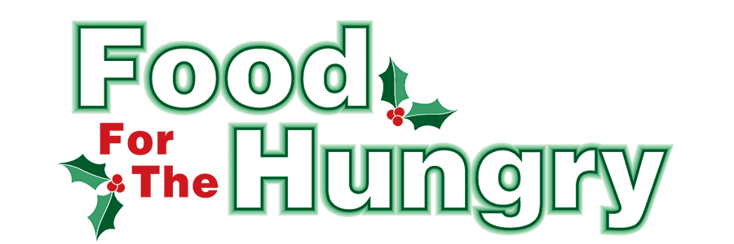

**PRESS RELEASE**

**Contact: Olivia Greenich Stern  
Food For The Hungry Digital Content & Marketing Director  
(330) 260-4059  
contact@foodforthehungrycares.org**

**October 3, 2024**

**FOR IMMEDIATE RELEASE**

**MOUNT VERNON: Collaboration of care at work in Knox County**

First Church of the Nazarene and East Knox Schools received grants from Food For The Hungry in its most recent grant process of the 2024 Spring/Summer cycle. The two organizations collaborated and used their grants for food distribution to students in need throughout the East Knox District. First Church gets food from Mid-Ohio Food Collective and delivers it to the school on Fridays during the school year. East Knox uses the school buses to transport the food home with the kids. During the Summer, these bags were personally delivered upon request and approval.

Last year Renee Reiss, Director of Foster Ministry Center at First Church of the Nazarene was contacted about the possibility of providing weekend meals to students within the East Knox school district whose families didn’t have enough resources for food. She worked with East Knox school nurse Dani Dawson, resource officer Josh Jones, and Superintendent Jim Peterson to ‘test the concept’ during the Spring. After a successful Spring, Dawson, Reiss, and Jones worked out a Summer program designed to help those students within the East Knox district.

The leadership of the program has changed as Peterson retired this Summer and Dawson moved into a teaching position at the Knox County Career Center this Fall. Before their departures, they recruited East Knox’s new superintendent Richard Baird, elementary school social worker Katie Kilgore, elementary principal Missy Moreland, and officer Jones to continue the program.

This year is ‘bigger and better’ in terms of students who signed up to be a part of the program. The school sent a letter to ALL students within the district and 30.5% replied asking for assistance with food. Only two did not meet the federal guidelines to participate. The deliveries are averaging 75-80 bags per week.

Throughout the week, First Church volunteers pack the bags of food. Each Friday, volunteers from First Church drive the food to the schools for distribution. The bags contain enough food for three meals a day for three days with some items picked by the students themselves. Reiss states ‘there is a balance we try to strike. We have fresh produce and protein along with cereal and snacks, like popcorn. We don’t want to pack food that will get wasted.’

After discussions on the students’ needs with Dawson, Reiss and her crew at Foster Ministry Center are also providing personal hygiene products for students who have requested them.

Food For The Hungry is proud to support projects like this. Thank you to all who donated food and funds during our annual drive. Without you, collaborations like this wouldn’t be successful and students wouldn’t come to school on Mondays ready to learn!

Follow FFTH on Facebook (@FoodForTheHungryKnoxCounty) and Instagram (@FFTHCares) to stay current on all things FFTH. To learn more about FFTH, donate, or find photos, videos, and more, visit [www.FoodForTheHungryCares.org](http://www.foodforthehungrycares.org).

***Food For The Hungry—Working together to care for our neighbors.***

###